FGD and DeNOx
NEWSLETTER
April 2022
No. 527

Table of Contents

MARKETS

- Air, Water, Energy (AWE) Suppliers Can Guide Program to Replace Russian Energy
- U.S. Has Largest Reserves of Recoverable Oil

INDUSTRY NEWS
- Xebec Announces $113.5M Order for CO₂ Capture and Sequestration Equipment with Summit Carbon Solutions
- To Cut Emissions at Louisiana Coal Plant, Utility Plans to Build $900M Carbon Capture Facility
- ExxonMobil Begins Design Studies for South East Australia Carbon Capture Hub in Gippsland
- Capio Sequestration Pursuing Carbon Capture Projects
- IPCC Says Carbon Capture is Necessary
- Tachyus Launches Dioxeon to Optimize CO₂ Injection in Mature Fields
- Ethanol From Sugar Producing Countries is One Option From Reducing Dependence on Russian Energy
- Strategic Acquisition of Future Industrial-Scale Green Hydrogen Production in the Caribbean
- Grön Fuels Produces Aviation Fuels From Biomass
- Valmet Chosen by POSCO Engineering & Construction to Supply an Automation System to a New Waste-To-Energy Plant in Warsaw, Poland
- Babcock & Wilcox Environmental Awarded $12 Million Contract to Supply Advanced, Low-Emissions Cooling Systems in South Korea
- Ahlstrom Fuel Cell Intake Media Has HEPA Efficiency
- Hydrogen in a Box Could Be a Winner
- What Percent Hydrogen Can Be Cost Effectively Used in Power Plants

Renewable Innovations, Quantum Fuel Systems Partner to Accelerate the Hydrogen Economy
- Bloom Energy Electrolyzer Accelerates the Future of Hydrogen Production in South Korea
- Fertilizer Manufacturer Orders Magnesium Oxide FGD System

MARKETS

Air, Water, Energy (AWE) Suppliers Can Guide Program to Replace Russian Energy
AWE products are critical in producing various fuels to replace Russian oil and gas. The free world is united in a program to achieve this replacement. People are motivated in a way not seen since the OPEC oil embargo in 1973. At that time, an alternative fuels program was immediately launched. In retrospect the technology choices were not optimum. The AWE industry can lead governments and purchasers to the best choices in the current crisis.
In 2021, Russian crude and condensate output reached 10.5 million barrels per day (bpd), making up 14% of the world’s total supply. Russia has oil and gas production facilities throughout the country, but the bulk of its fields are concentrated in western and eastern Siberia. In 2021 Russia exported an estimated 4.7 million bpd of crude to countries around the world. China is the largest importer of Russian crude (1.6 million bpd), but Russia exports a significant volume to buyers in Europe (2.4 million bpd).
Russia is the world’s second-largest producer of natural gas, behind the United States, and has the world’s largest gas reserves. Russia is the world’s largest gas exporter. In 2021 the country produced 762 bcm of natural gas and exported approximately 210 bcm via pipeline.
Russia has a wide-reaching gas export pipeline network, both via transit routes through Belarus and Ukraine, and via pipelines sending gas directly into Europe (including Nord Stream, Blue Stream, and TurkStream pipelines). Russia completed work on the Nord Stream II pipeline in 2021, but the German government decided not to approve certification in the wake of the Russian invasion of Ukraine. Russian natural gas accounted for 45% of imports and almost 40% of European Union gas demand in 2021.
It will be more difficult for Russia to sell its gas if Europe does not purchase it. Oil is more easily delivered around the world. However, oil sold to China or India at a discount will substantially reduce Russian revenues. Furthermore the lack of international products, including pumps, will make production less efficient.
AWE products will play a major role in providing alternative fuels for Europe and other free countries.
Impact of Alternative Fuels on the AWE Industry
Classification | Technology | 10 year impact on the AWE market -  $ billions
Life extension of alternatives | Nuclear | 15
Life extension of alternatives | Coal | 18
Substitute fuels for gas-fired plants | Hydrogen from electrolyzers | 3
Substitute fuels for gas-fired plants | Hydrogen from steam methane reformation | 15
Substitute fuels for gas-fired plants | Ammonia | 6
Substitute fuels for gas-fired plants | Gasified coal and CCS | 9
Solid fuel plants | Coal with CCS | 12
Solid fuel plants | Biomass with CCS | 27
Energy efficiency | Improved AWE designs | 6
Energy efficiency | Combined Heat and Power | 10

This is the impact over 10 years of replacing Russian energy. Even though the primary activity will be in Europe, higher gas and oil prices around the world will also incentivize other countries to select alternative options. The largest potential is bioenergy with carbon sequestration. The 4,000-MW Drax power plant in the UK is now burning wood pellets primarily imported from the U.S. It is completing a project to sequester CO₂ in the North Sea. This is a carbon negative technology.
A 4,000-MW BECCS plant reverses the CO₂ contribution to the atmosphere. The significance is twofold.\Even though a temporary alternative fuels program can add CO₂ there is no tipping point. BECCS can bring down CO₂ levels in the future.
- Any BECCS will offset carbon producing options. So 4,000-MW of conventional coal plant life extension plus 4,000-MW of BECCS = 8,000-MW of carbon neutral electricity.
The U.S. faced a similar situation in 1973 when OPEC banned oil exports to a country supporting Israel. A number of technology choices were made without access to an organized evaluation system. Highest on the priory list were
- oil shale (not shale oil)
- new coal-fired power plants
The plan was to make Colorado the oil capital of the world with a technology used for tar sands in Canada. Huge construction sites were built in a short time. Electric heat was to replace gas heat. 85,000-MW of new coal-fired power plants were ordered by U.S. utilities. Six months later the oil embargo was lifted. No oil shale plants were built in Colorado. In the 50 years since the big coal plant orders, less than 30,000-MW of new coal plants have been built. So cancellations have exceeded new orders.
In similar crisis situations, South Africa and Nazi Germany made a different choice. Germany opted for coal-to-liquids (CTL). During World War II most of the airplane and tank fuel was produced by CTL. South Africa, during the apartheid era, built the huge Sasol complex and made both fuels and chemicals. Today that technology is being extensively employed in the Chinese chemical industry.
The only relic of the 1973 program is the Great Plains plant in North Dakota. It has produced coal gas, ammonia, and hydrogen from coal. It has piped CO₂ for enhanced oil recovery to Canada. The plant is being revamped to use shale gas to produce hydrogen and ammonia.
If it had not been for the inventions around shale fracturing in the 1990s, the failure of the U.S. to develop an alternative fuels program would have resulted in $200/barrel oil today and a dominance of Russia and OPEC. The free world cannot afford to make the same haphazard decisions made in 1973.
The AWE suppliers should have been in a guiding role in 1973. They knew coal gasification and liquefaction was reliable whereas retorts for oil shale were problematic. It is easy to ignore all the available knowledge. Coal gasification was widely used for town gas starting in the 1890s. It was critical to remove flyash and SO₂. A high energy scrubber was invented for the purpose. Within a few decades, natural gas and fuel oil replaced coal gas and the scrubber was forgotten.
In 1945, the U.S. was looking for a way to remove particulate and acid gases in steel and pulp mills. Johnstone of U of I became famous for inventing or actually reinventing the venturi scrubber.
In the 1970s one variation captured acids and particulates incidentally including rare earths. In the 1990s Siemens adopted it for coal gas but ignored the potential for insitu rare earth production along with a leaching solution free of charge. Today rare earth production is important, and suppliers have a low cost solution if they would just use what they know.
AWE suppliers should be at the forefront in crafting alternatives to Russian energy. The McIlvaine Company can support their efforts with assistance relative to

- market forecasts
- predicate evidence
- disputed evidence
Market Forecasts. Suppliers want to pursue the most profitable markets (MPM). McIlvaine can identify the specific opportunities for a particular design of filter, valve, or compressor. There is the potential for shale oil and gas to replace much of Russian energy. How big is this potential? What is the market for fracking pumps which develop higher pressures and fracture shale deeper into the earth?
Will natural frac sands be available or will there be a need for filters, pumps, and valves to process synthetic sands?
Predicate Evidence. Market forecasts need to focus on opportunities where a lowest total cost of ownership (LTCOV)I is achievable. This is determined in part by predicate evidence such as what flow rates and pressures are needed. This predicate evidence is also the foundation for addressing the disputed evidence.
Disputed Evidence. The supplier needs to convince purchasers that his product will have the lowest total cost of ownership. This entails analysis of competitors. McIlvaine identifies competitors and the claims they are making relative to the cost of ownership for their products.
Providing alternatives to Russian energy is an extremely valuable contribution to the world and one which can be profitable for AWE suppliers.
McIlvaine has market reports which can be used as the basis for the full pursuit of the alternative energy solutions.
For more information contact Bob McIlvaine at 847 226 2391 or rmcilvaine@mcilvainecompany.com
What is the Best BECCS Approach?
BECCS assumes a much more important role in the battle to reduce Russian energy use while meeting long range carbon reduction commitments. Since it is carbon negative, it can offset near term CO₂ emissions associated with expedient energy alternatives, such as extension of coal-fired plant life in Europe.
Even absent the Russian challenge, environmentalists say BECCS will be necessary. Some carbon negative projects will be needed. BECCS costs will be only a fraction of direct separation.
The order for a 200-MW BECCS plant associated with Grön Fuels just announced by B&W presents an alternative to the approach used at Drax where amine scrubbing will be used to capture the CO_{2.}
Oxycombustion is utilized in the B&W process. It was tested at the 30-MW scale in 2008-9 at an Illinois power plant. DOE then provided initial funding for a full scale plant but canceled the project in 2014.
An air separation unit is used to provide pure oxygen for combustion. This eliminates the need for the amine scrubber to separate the nitrogen from the CO₂ in the Drax approach.

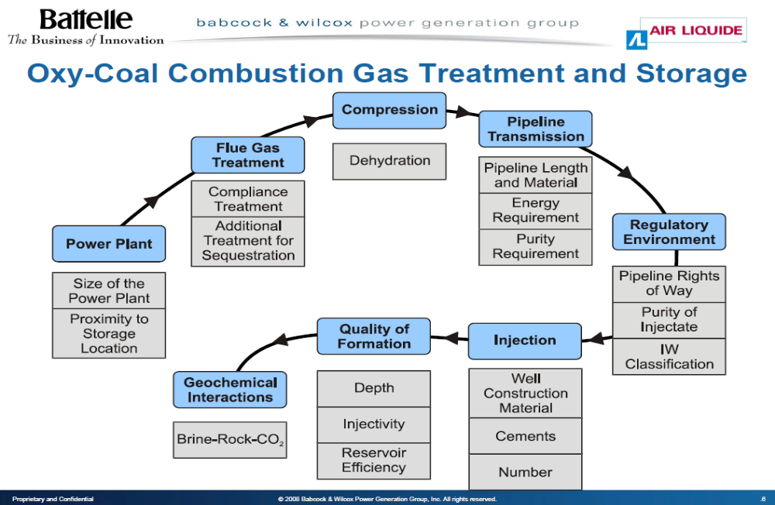

There are challenges in oxycombustion, which need to be evaluated. CO₂ recirculation is necessary. A benefit is the fact that the entire gas stream is sequestered, so there are no air pollutants. The oxycombustion approach is less proven than the Drax approach.
The SaskPower Boundary Dam CCS unit is a commercial 300-MW coal-fired generating delivering CO₂ for EOR in Canada. Shell was the supplier of the CO₂ absorber. A number of other companies have experience with Carbon Dioxide Recovery (CDR).
The oxycombustion approach will have to show significant benefits to deserve consideration. It is asserted that the energy cost of the air separation is more than offset by the elimination of the amine CO₂ capture scrubber.
This is a question which is being reshaped as both new air separation and CO₂ absorbers are being developed. Mitsubishi is installing a CO₂ absorber at Drax which reflects decades of evolution.
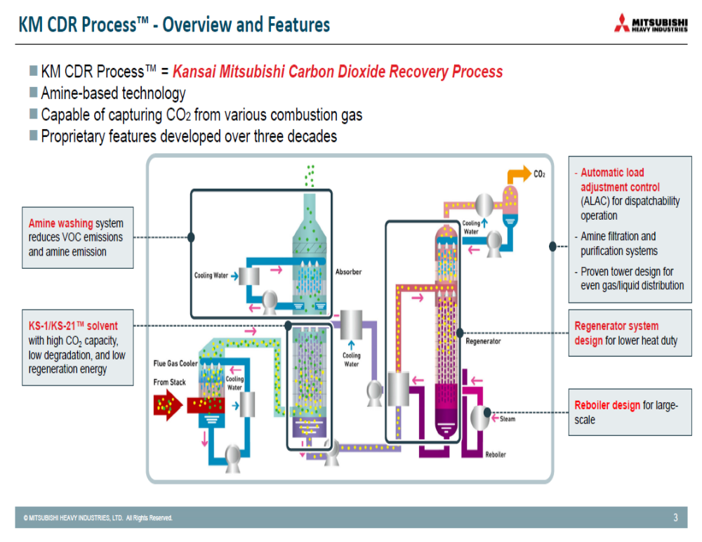

Mitsubishi is providing the Drax the Carbon Dioxide Recovery (CDR) based on extensive experience.
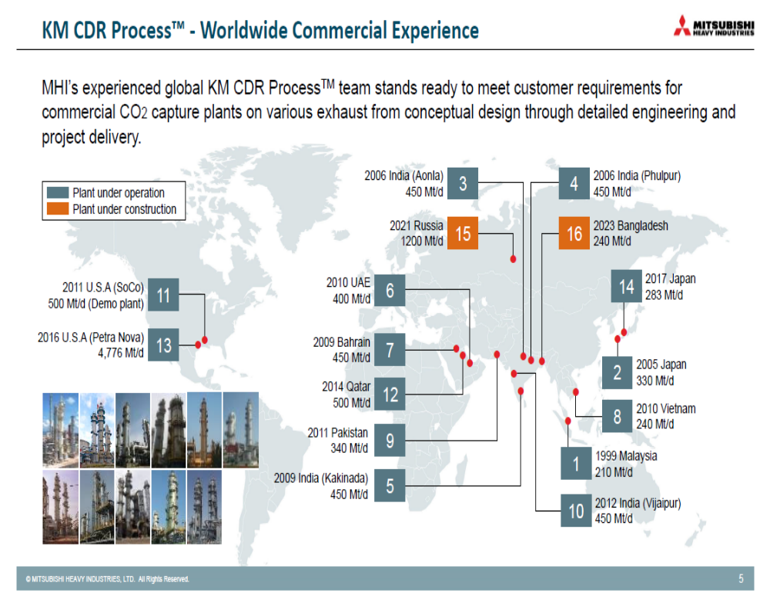
One of the advantages of BECCS is the ability to move forward in stages. European power plants can quickly substitute biomass for some of the coal and then progressively increase the biomass percentage. The carbon capture and sequestration can then be installed at a much later date.
U.S. Has Largest Reserves of Recoverable Oil
The United States now holds the world’s largest recoverable oil reserve base — more than Saudi Arabia or Russia — thanks to the development of unconventional resource plays.
Ranking nations by the most likely estimate for existing fields, discoveries, and as-of-yet undiscovered fields, (proved, probable. possible and undiscovered), the United States is at the top of the list with 264 billion barrels of recoverable oil reserves, followed by Russia with 256 billion, Saudi Arabia with 212 billion, Canada with 167 billion, Iran with 143 billion, and Brazil with 120 billion (see Table below).

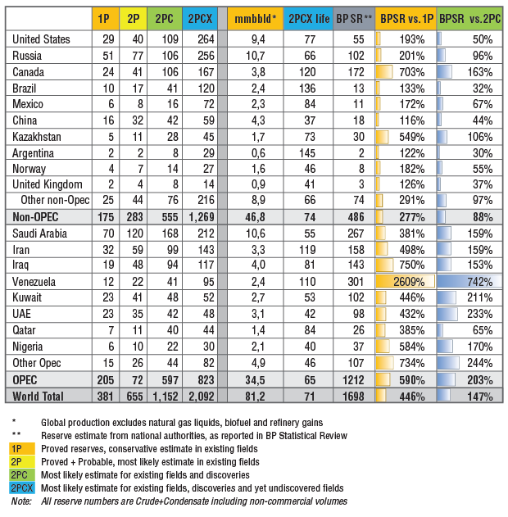
Importantly, unconventional plays account for more than 50 percent of remaining U.S. oil reserves, with Texas alone holding more than 60 billion barrels of recoverable oil in shale plays.
The reserves data distinguish between reserves in existing fields and new projects, and potential reserves in recent discoveries and still undiscovered fields. The estimates include crude oil plus condensate.
An established standard approach for estimating reserves is applied to all fields in all countries, so reserves can be compared apple-to-apple across the world, both for OPEC and non-OPEC countries.
Other public sources of global oil reserves are based on official reporting from national authorities, with reserves reported based on a diverse and opaque set of standards. For example, some OPEC countries, such as Venezuela, report official reserves apparently including yet-undiscovered oil, while China and Brazil officially report conservative estimates and only for existing fields.
Total global oil reserves are estimated at 2,092 billion barrels, or 70 times the current production rate of about 30 billion barrels of oil a year. For comparison, cumulatively produced oil through 2015 amounted to 1,300 billion barrels.
Unconventional oil recovery accounts for 30 percent of the global recoverable oil reserves, while offshore fields account for 33 percent of the total. The seven major oil companies hold less than 10 percent of the total recoverable reserve base.
Considering only proved reserves (1P), the study ranks Saudi Arabia at the top with 70 billion barrels, followed by Russia with 51 billion, Iran with 32 billion, the United States with 29 billion and Canada with 24 billion. Ranked by proved plus probable reserves (P2), Saudi Arabia holds 120 billion barrels, followed by Russia with 77 billion, Iran with 59 billion, Canada with 41 billion and the United States with 40 billion.
INDUSTRY NEWS
Xebec Announces $113.5M Order for CO₂ Capture and Sequestration Equipment with Summit Carbon Solutions
Xebec Adsorption Inc., a global provider of sustainable gas technologies, is pleased to announce that its subsidiary Xebec Systems USA LLC, has signed a contract valued at USD113.5 million (CAD143.2 million) with Iowa-based SCS Carbon Removal LLC, a subsidiary of Summit Carbon Solutions. The contract follows a previously announced MOU signed on March 28, 2022, for 51 carbon dioxide (CO₂) reciprocating compression packages. This equipment will be used for Summit Carbon Solutions’ proposed carbon capture and sequestration project, which is expected to be the largest in the world if approved. This contract showcases Xebec’s expanding technology portfolio for carbon capture and sequestration.
“We are pleased to be a key supplier to Summit Carbon Solutions’ project for decarbonization,” stated Jim Vounassis, President, and CEO of Xebec Adsorption Inc. “With this important order, we look forward to helping bring this CO₂ pipeline to fruition and playing our continued part in the global energy transition,” he added. The equipment will be manufactured at Xebec Systems USA’s (formerly UECompression) Colorado facility.
To Cut Emissions at Louisiana Coal Plant, Utility Plans to Build $900M Carbon Capture Facility
A Louisiana utility plans to invest $900 million into capturing and storing carbon emissions from its largest power generation units in the state by 2028, the governor’s office announced Monday.
Cleco Power — which serves 291,000 customers across 24 parishes — will spend the next year and a half conducting a $9 million study to design a carbon capture and storage facility for its coal-fired Madison-3 unit at its power plant in Lena.
Coal is widely recognized as the most polluting fossil fuel, responsible for an oversized role in global warming. The Madison-3 is the single largest emitter of greenhouse gas in the state’s electricity generation sector, releasing 3 to 4 million tons annually, according to company officials.
Cleco Corporate Holdings LLC President and CEO Bill Fontenot said the facility will prevent at least 95% of the unit’s carbon emissions from entering the atmosphere. The technology would pull it from the air, cool the carbon near liquid form and store it in underground caves nearly a mile beneath its plant.
“Cleco’s Project Diamond Vault will ensure a clean and sustainable power solution for Cleco customers, while creating and retaining jobs for the communities we serve,” Fontenot said. “In Louisiana, we have the natural resources, the ingenuity, the geology, the people and the infrastructure to transform the power industry as we know it.”
The company estimates it would create 30 to 40 direct jobs and approximately 1,100 construction jobs in central Louisiana over a three-year period.
The announcement comes just over two months after the state approved its first Climate Plan amid Gov. John Bel Edwards’ push to cut greenhouse gas emissions statewide. He has ordered the state to have “net-zero” carbon emissions by 2050 as part of the global effort to limit the growing impacts of a warmer planet.
The consequences of climate change are especially acute in Louisiana, where the Gulf of Mexico is projected to rise up to 2 feet in the next 30 years, exacerbating its ongoing land loss crisis and making coastal communities even more vulnerable to increasingly intense hurricanes.
Edwards’ applauded the company’s announcement Monday, saying it will bring the state closer to his emission targets.
“Today’s announcement is an important milestone on Louisiana’s path to a cleaner energy future,” Edwards said. “Our state has attracted significant investment in the construction of new facilities that minimize emissions.”
Cleco’s $9 million study, expected to be complete by the end of 2023, will be paid for with taxpayer money from a congressional appropriation disbursed by Louisiana Economic Development.
After the study, the company expects permitting and environmental impact review to take until the middle of 2025. Construction would start immediately after approval, and the company plans to start operations by 2028.
The company will look to raise the $900 million for construction through tax credits, Department of Energy grants and private equity investment, according to the press release.
This isn’t the first carbon capture project proposed in Louisiana. Last year, chemical company Air Products announced plans to build a $4.5 billion “blue” hydrogen plant in Ascension Parish that would rely on capture and storage to produce low-carbon fuel. Other companies are looking at areas in southwest Louisiana to store carbon.
The use of public money to incentivize and pay for carbon capture projects in the industrial and energy sectors has been opposed by environmental and renewable energy advocates, arguing that subsidizing what they consider “unproven technology” is a waste of money that could go toward the energy transition and other climate solutions. becoming a carbon capture hub
Sierra Club organizer Darryl Malek-Wiley noted that it’s uncertain how long carbon emissions could be stored underground and whether leaks would occur.
“Fossil fuel companies can’t keep methane from leaking into our atmosphere when stored temporarily, so I’m not confident that a project like this is going to be able to sequester carbon dioxide on a timescale needed to avert the worst impacts of climate change,” he said in a statement.
In addition to the Madison-3 unit, Cleco manages three other coal-fired power generation units — the last in Louisiana. It recently retired its Dolet Hills coal plant at the end of 2021 because the cost wasn’t competitive. The company has pledged to retire its other three coal-fired units — Big Cajun II and Rodemacher — by 2025 and 2028, respectively, to comply with federal rules on coal ash ponds.
ExxonMobil Begins Design Studies for South East Australia Carbon Capture Hub in Gippsland
ExxonMobil said it is undertaking early front-end engineering design studies (pre-FEED) to determine the potential for carbon capture and storage to reduce greenhouse gas emissions from multiple industries in the Gippsland Basin.
The South East Australia carbon capture and storage (SEA CCS) hub would initially use existing infrastructure to store CO₂ in the depleted Bream field off the coast of Gippsland, Victoria. The company is in active discussions with local industries which may be interested in accessing the SEA CCS hub to reduce emissions from their operations.
The project is designed to capture up to two million metric tons of CO₂ per year. If technical and business feasibility is confirmed, the SEA CCS hub could be operational by 2025.
“Collaboration with other industries is an important step to unlock future carbon capture and storage opportunities for Australia, with the potential for large-scale reductions in the highest emitting industrial sectors,” said Joe Blommaert, president of ExxonMobil Low Carbon Solutions. “Sound government policies will accelerate the deployment of key technologies required to support society’s ambition for a net-zero future.”
ExxonMobil established its Low Carbon Solutions business to commercialize the company’s extensive lower-emission portfolio with the objective to create long-term shareholder value and support global emission-reduction efforts.
Low Carbon Solutions is focused on commercializing lower-emission business opportunities in carbon capture and storage, hydrogen, and lower-emission fuels, by leveraging the skills, knowledge, and scale of ExxonMobil. The company has more than 30 years of experience capturing CO₂ and has cumulatively captured more human-made CO₂ than any other company. It has an equity share of about one-fifth of the world’s carbon capture and storage capacity at about 9 million metric tons per year.
Capio Sequestration Pursuing Carbon Capture Projects
Capio Sequestration, LLC develops carbon capture and sequestration assets for both Fidelis and non- Fidelis partners throughout North America and Europe. The firm utilizes proven bankable technologies with referenceable operational histories to address the climate crisis by mitigating the emissions products by chemical production, petroleum refining, and all other industrial producers of greenhouse gas emissions. The initial CCS assets are being developed in the industrial corridor between Baton Rouge and New Orleans along the Mississippi River. Capio draws its competitive advantage through its involvement in the Grön Ecosystem, from which is it expected to sequester significant volumes of biogenic CO₂ from the Grön Fuels Renewable Diesel Facility, based in Baton Rouge, Louisiana. Capio further seeks to generate mutual value for such hosts through 45Q tax credits, LCFS credits and other environmental economic attributes generated by the capture, sequestration, and beneficial use of CO₂.
IPCC Says Carbon Capture is Necessary
Emissions cuts alone won’t limit global warming to 1.5°C, IPCC report warns. But can carbon removal from land use and technology scale up in time? This is the question addressed by Jeff St. John in a Canary Media article.
He points to the new IPCC report which says efforts to eliminate carbon emissions will not be enough on their own to keep global warming below 1.5 degrees Celsius. It asserts that investments to actively remove carbon dioxide from the atmosphere are now ​“unavoidable” if the world is to achieve net-zero greenhouse gas emissions by 2050.
A recent paper from the Energy Transitions Commission, a coalition of major energy, metals, mining, transportation, and technology companies cites the need for ​“at least 70 to 220 [gigatons] of carbon removals between now and 2050 to limit cumulative net emissions” to levels ​“consistent with a 1.5°C climate objective,” given the current expectations for continued emissions even under the ​“most ambitious possible reductions.”
The ETC report calls for project financing for carbon removal to grow from less than $10 billion per year today to as much as $200 billion per year by 2030 to allow the sector to meet its full potential for keeping global warming in check.
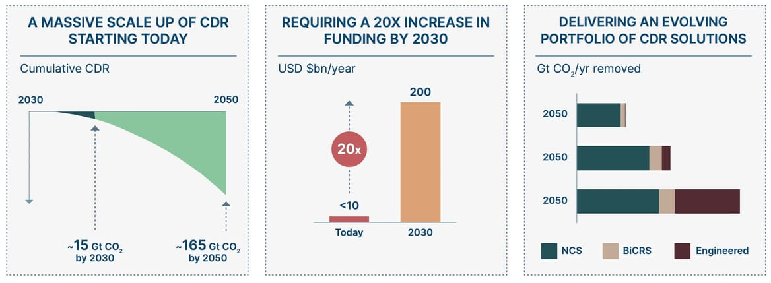
Bioenergy with carbon capture and storage — a term that describes growing plants and converting that biomass to energy while capturing the resulting carbon emissions — could also contribute between 30 and 780 gigatons of cumulative net-negative emissions through 2100 in a 1.5-degree scenario, the report states.
https://www.canarymedia.com/articles/carbon-capture/carbon-removal-now-unavoidable-part-of-fighting-climate-change-un-says
Tachyus Launches Dioxeon to Optimize CO₂ Injection in Mature Fields
Tachyus announced that it has signed a contract with a customer in the U.S. to optimize CO₂ injection in one of its fields in the state of Texas.
Carbon Dioxide flooding is widely used as an Enhanced Oil Recovery methodology. When injected at the right pressure, the CO₂ mixes with the remaining oil, increasing recovery factor and at the same time, providing a safe place to store the CO₂ as part of Carbon Capture and Sequestration (CCS) initiatives. Given the fact that combined EOR - CCS projects increase production while reducing GHG emissions, the number of projects is seeing significant growth in recent years.
Traditional methods try to minimize the amount of CO₂ injected and to maximize the oil produced; but CCS projects will actually look at maximizing both the carbon stored and the oil produced. Dioxeon, powered by Data Physics, helps operators build predictive models in a few weeks and run scenarios in minutes enabling the possibility of applying advanced optimization techniques to generate the most efficient frontier (so-called pareto front) and optimize multiple objectives by prescribing recommendations on CO₂ injection rates for each well and at each period of time.
Following the international success of Aqueon, Tachyus waterflood optimization tool, the company expects Dioxeon to become widely used in North America where a large number of CO₂ flooding projects are being executed.
Ethanol From Sugar Producing Countries is One Option From Reducing Dependence on Russian Energy
With Guyana seeking to diversify its faltering sugar industry and the PPP/C reopening closed estates, General Electric’s (GE) Regional Product Director, John Ingram, advised that ethanol can be used to aid the transition to renewable energy, and he was bullish on the proposed use of natural gas here.
The sugar industry is an important industry in Guyana, and it’s a possibility also to use that fuel as a renewable fuel.
Providing some insight into the transition of Guyana’s energy sector, heavy fuel oil (HFO) power plants, like those in Guyana, are the largest emitters of carbon in the atmosphere and by eliminating those plants, Guyana stands to reduce its emissions by 50%.
Strategic Acquisition of Future Industrial-Scale Green Hydrogen Production in the Caribbean
Hydrogène de France (HDF Energy) - announced that it has acquired a 70% majority stake in the NewGen project in Trinidad, led by the local company Kenesjay Green Ltd (KGL). KGL, the project developer, will retain the remaining 30% of the share capital of NewGen, which will be jointly owned by KGL and an investment vehicle that will allow for the inclusion of additional local investors. HDF Energy is thus leveraging its technological expertise in hydrogen, its know-how in the development of green energy plants, and its local presence in the Caribbean.
When completed, the 200+ Million USD NewGen plant will be the world largest clean hydrogen producing facility of its kind, using a smart combination of solar and energy efficiency-sourced power. It will competitively generate carbon-free hydrogen to meet 20% of the hydrogen requirement for an existing world-scale ammonia plant in the petrochemical hub of Point Lisas, Trinidad. Once up and running, the project will save approximately 200 000 t/CO₂ per year.
As a global pioneer in hydrogen power, HDF will add its in-depth experience in hydrogen technologies, procurement, and project finance, to the Trinidad-specific energy and ammonia expertise contained within the KGL project development team. This is the third major investment in the Caribbean this last year for HDF, which announced hybrid “Renewstable®” baseload power plants using green hydrogen and solar power in French Guiana and Barbados alongside its regional partner and investor, RUBIS.
Together, KGL and HDF will select the optimal electrolysis technology provider from a competitive evaluation process. KGL has also recently been granted the outline planning permission for the NewGen Project by the Ministry of Planning of Trinidad and Tobago and has made progress in further confirming the economic and financial viability of NewGen.
Commenting on the HDF majority acquisition, KGL’s Chairman Philip Julien said, “KGL welcomes this significant endorsement and investment in NewGen by HDF and looks forward to our collaboration and sharing of expertise. Our partnership enables improved local access to international finance and technology, optimum opportunities for local ownership, and an acceleration of Trinidad and Tobago’s energy transition commitments.”
Damien HAVARD, CEO of HDF Energy said: “We believe we have the ideal partners in Kenesjay Green, given their extensive knowledge of the industry, business acumen and their commitment to local development. Our investment in NewGen affirms our belief that Trinidad and Tobago’s energy industry offers a unique opportunity for the development of world scale and cost competitive carbon-free Hydrogen. This project demonstrates that green solutions can effectively support the transition of hydrocarbon-based economies like Trinidad and Tobago – and HDF is poised to be a part of leading the change.”
Grön Fuels Produces Aviation Fuels From Biomass
Grön Fuels, LLC is a 73,000 barrel per day renewable fuels facility producing Sustainable Aviation Fuel, Renewable Diesel, and Green Hydrogen as low carbon transportation fuels. Grön Fuels, LLC is using Haldor Topsoe’s Hydroflex technology and Alfa Laval pretreatment technology, heat transfer and water treatment equipment in the design of the plant. The Project benefits from substantial existing infrastructure at its host site, the Port of Greater Baton Rouge, including a recently completed unit train terminal, a large grain elevator at the site, a deepwater port accommodating Panamax size vessels, and interconnection with the Bengal Pipeline, providing access to the Colonial Pipeline System and the Plantation Pipeline. Because the project is not integrated with fossil refinery complexes, it has leveraged the Fidelis RACER™ design framework (utilizing proven technologies) to optimize efficiency, maximize the mitigation of CO₂ throughout the plant, and develop a long-term capital investment program to continuously improve its emission profile.
Valmet Chosen by POSCO Engineering & Construction to Supply an Automation System to a New Waste-To-Energy Plant in Warsaw, Poland
Valmet will deliver an automation system to a new waste-to-energy plant in Warsaw, Poland. The order was placed by POSCO Engineering & Construction (POSCO E&C), a Korea-based engineering, procurement, and construction contractor.
The plant is owned and operated by the waste management company Miejskie Przedsiębiorstwo Oczyszczania in the city of Warsaw (MPO Warszawa).
The order is included in Valmet’s orders received in the first quarter of 2022. The value of the order will not be disclosed. The delivery of the hardware will take place in the first quarter 2023.
“It’s crucial to have the right and reliable partner to secure a successful project delivery. We have been satisfied with our previous collaboration with Valmet in another waste-to-energy project in Krakow, Poland, and hence we are glad to work with Valmet again,” says Junho Moon, General Manager, POSCO E&C.
“We are delighted to be selected as automation supplier by POSCO E&C for the second time, thanks to our proven technology and strong references globally and locally. With Valmet’s advanced automation system, the plant will be able to process efficiently and eco-friendly,” says Wanmo Yoon, Sales Manager, Korea, Energy & Process Systems, Automation Systems business line, Valmet.
Towards sustainable energy production
Valmet’s delivery consists of a Valmet DNA Automation System and an information management system to control the boiler of the new plant. It helps to ensure efficient and environmentally sound energy production from waste-derived fuels.
The new waste-to-energy plant will be started up for commercial operation in 2024. It will process 305,000 tons of municipal solid waste from Warsaw per year to produce electricity and district heating. The new plant will make substantial contribution to sustainable waste management.
Babcock & Wilcox Environmental Awarded $12 Million Contract to Supply Advanced, Low-Emissions Cooling Systems in South Korea
Babcock & Wilcox (B&W) announced that its B&W Environmental segment has been awarded a contract for more than $12 million by Lotte Engineering & Construction Co. to supply hybrid cooling systems for Korea District Heating Corporation’s (KDHC) power generation and district heating projects in Daegu and Cheongju, South Korea.
B&W Environmental will design and supply two SPIGTM hybrid cooling towers that utilize advanced wet and dry cooling technologies to efficiently cool the plants while reducing water consumption, minimizing plume formation, and decreasing noise emissions.
“B&W Environmental is seeing significant business growth in East Asia, as demand for hybrid cooling technology grows,” said Babcock & Wilcox Executive Vice President and Chief Operating Officer, Jimmy Morgan. “Our SPIG hybrid cooling systems are flexible and reliable, and particularly well-suited for locations where reduced plume formation is important, such as in residential areas.”
Since opening its Asia-Pacific headquarters in 2020, B&W has added significant resources and personnel in the region, while focusing on key growth areas for its business, such as plant upgrades, advanced emissions control and cooling technologies, parts, equipment, and other services to customers in the renewable, environmental, power, and industrial markets.
Ahlstrom Fuel Cell Intake Media Has HEPA Efficiency
Cedric Vallet of Ahlstrom Munksjo has listed features which make the FiltEV media ideal for the air intakes of fuel cells: “I am very pleased to introduce our new filtration solution for fuel cell air intake,” said Cedric Vallet, Head of Business Development, Industrial Filtration & New Vehicles. “By protecting fuel cells from harmful gases and particulates, we ensure an effective operation of the fuel cell, and we extend its lifetime, optimizing the cost/benefit for the end-users,” he added.
Air intake provides the oxygen to the fuel cell. Outside air can be polluted by various gases, including hydrocarbons, sulphur dioxide (SO₂), nitrogen oxide (NO_{x}), and ammonia (NH₃), which are known poisons of the fuel cell catalyst. Based on a new proprietary multi-layer dry technology platform and customized adsorbent blends, Ahlstrom-Munksjö FiltEV® Fuel Cell Air Intake media delivers exceptional adsorption properties on all these gaseous pollutants to reach always more challenging cathode air quality requirements.
Outside air is also polluted by a high number of particles that can enter the fuel cell, fouling the channels and the proton exchange membrane. Ahlstrom-Munksjö’s FiltEV® Fuel Cell Air Intake media integrates high particulate efficiency layers, which deliver HEPA level performance, removing up to 99.95% of the smallest particles.
In 2021, Ahlstrom-Munksjö expanded its testing capacity as part of the company strategy to invest and grow in the industrial filtration and electric vehicle markets. A new test bench to evaluate gas adsorption performance was installed at the R&D center of the company in France. The investment was completed to assist strategic, high-priority R&D projects to develop next-generation molecular filters for fuel cell air intake filters, premium cabin, and clean room environments.
https://www.ahlstrom-munksjo.com/Media/articles/ahlstrom-munksjos-new-filtration-solution-for-fuel-cell-air-intake-supports-the-growing-market-of-fuel-cell-electric-vehicles/
Hydrogen in a Box Could Be a Winner

If LNG in a Box has applications why not Hydrogen in a Box. This could eliminate some of the risks involved in blending hydrogen in pipelines. A decade ago GE launched LNG in a Box. Coal gasifiers in China are liquefying gas and trucking it to power plants. An iron mining diesel truck in Australia could save $500,000 per year in fuel costs if it switched to LNG.

Currently, for longer distances, hydrogen is transported as a liquid in super-insulated, cryogenic tanker trucks. After liquefaction, the liquid hydrogen is dispensed to delivery trucks and transported to distribution sites where it is vaporized to a high-pressure gaseous product for dispensing.

Over long distances, trucking liquid hydrogen is more economical than trucking gaseous hydrogen because a liquid tanker truck can hold a much larger mass of hydrogen than a gaseous tube trailer can. Challenges with liquid transportation include the potential for boil-off during delivery.

What Percent Hydrogen Can Be Cost Effectively Used in Power Plants
A report by Energy Innovation is negative relative to the use of hydrogen for blending into natural gas pipelines. It cites a level of 20% and above where major changes are necessary for use in power plants without major upgrades. However a reduction of 20% use of natural gas for power plants would be very significant. The question is cost vs. CO₂ reduction. Could 10% be burned with no upgrade costs? What upgrade cost is needed to move to 20%? Experts say blending hydrogen into gas pipelines won't… | Canary Media

Renewable Innovations, Quantum Fuel Systems Partner to Accelerate the Hydrogen Economy
Quantum Fuel Systems (Quantum), a fully integrated alternative energy company, and Renewable Innovations, a firm dedicated to clean, green hydrogen power solutions, announced a partnership to bring to market new solutions for hydrogen distribution. As the world quickly moves to hydrogen as a clean, green source of power, the infrastructure must also accelerate to meet the needs of the growing hydrogen economy. To help address this challenge, Renewable Innovations will incorporate Quantum Hydrogen storage vessels in its mobile Fuel Cell and H2 transport systems.

"Quantum has over 20 years of Hydrogen experience and are now on the cutting edge of looking at power generation and backup power applications in addition to their specialty in mobile applications," noted Robert Mount, Founder, President & CEO of Renewable Innovations. "We look forward to working with Quantum to grow and improve hydrogen infrastructure for application and on-site storage, as well as refueling and transport."

Both firms envision this partnership as a critical stage in delivering hydrogen-power-based solutions to the market. "Renewable Innovations is known for bold thinking and making an impact," commented Mark Arold, President of Quantum. "They have moved beyond imagining what a green clean future powered by hydrogen looks like and are building it today and we are excited to provide the mobile hydrogen capacity for this project and look forward to working together as strategic partners for future projects."

Quantum has a long history with hydrogen starting in 1999 when they launched the world's first 5,000 psi hydrogen system on a commercial vehicle and then later as the first to certify a 10,000 psi hydrogen storage tank to international standards.

In December 2021, Quantum delivered its first hydrogen virtual pipeline trailer to a North American customer. Similarly, Renewable Innovations has emerged as the leader in integrating and commercializing automotive hydrogen fuel cells for mobile and stationary uses, including rapid EV charging solutions.

Bloom Energy Electrolyzer Accelerates the Future of Hydrogen Production in South Korea
Bloom Energy announced the first international deployment of its high temperature temperature solid oxide electrolyzer. The successful 130 kilowatt (kW) installation in Gumi, South Korea, further propels Bloom Energy’s efforts to enable a hydrogen-fueled economy following the commercial launch of the Bloom Electrolyzer in 2021.

Bloom’s high-temperature electrolyzer is operating at its designed high efficiency, producing hydrogen onsite more efficiently than low-temperature PEM and alkaline electrolyzers. Because it operates at high temperatures, the Bloom Electrolyzer requires less energy to split water molecules and produce hydrogen. As electricity accounts for up to 80 percent of the cost of hydrogen from electrolysis, using less electricity increases the economics of hydrogen production and helps bolster adoption.

Fully operational at the Bloom SK Fuel Cell center in South Korea since January 2022, this new demonstration is testing electrolysis efficiency using water as an input in intermittency mode. The Bloom Electrolyzer is effectively and efficiently operating in daily cycles, demonstrating its ability to pair with intermittent renewables, such as solar and wind.

In production, the Bloom Electrolyzer is expected to operate at 46 kilowatt hours (kW-hr) per kilogram of hydrogen (kg H2) output with water as its input. When steam is used, the electrolyzer requires even less electricity, expected to operate at 40.4 kW-hr/kg H2, driving further efficiencies.

“The successful deployment of our electrolyzer internationally is a testament to the confidence it has garnered to create viable pathways to achieving a net-zero, hydrogen-fueled future,” said Deia Bayoumi, vice president, global product management, Bloom Energy. “This marks a critical step in our mission to transform the global energy landscape and enable the hydrogen economy.”

The project aligns with South Korea’s efforts to decarbonize its energy system and become a global leader in the hydrogen economy in the coming decades. Investing heavily in new technologies and infrastructure to spur the production and adoption of the carbon-neutral fuel, South Korea aims to replace fossil fuels with hydrogen as its chief power source by 2050, according to the Ministry of Trade, Industry, and Energy. With the capacity to scale hydrogen production rapidly, Bloom Energy and SK ecoplant are well-suited to drive South Korea’s energy transition forward.

“A significant milestone in our successful partnership with Bloom Energy, this latest collaboration is a testament to our shared vision to transform South Korea’s energy landscape and unlock new value through innovation,” said Seoung-hwan Oh, vice president, hydrogen business, SK ecoplant. “Bloom Energy’s technology has demonstrated unparalleled performance and efficiency, further establishing us at the forefront of South Korea’s clean energy market.”

Highly flexible, the Bloom Electrolyzer offers unique advantages for deployment across a broad variety of hydrogen applications, using multiple energy sources including intermittent renewable energy and excess heat. Its modular design also makes it ideal for applications across gas, utilities, nuclear, wind, solar, ammonia and heavy industries.

Fertilizer Manufacturer Orders Magnesium Oxide FGD System

Grupa Azoty S.A. has completed commissioning work on the flue gas desulfurization plant for boiler K-5.

In addition, the operational availability of the plant’s process equipment and systems for absorption was confirmed. Flue gas is desulfurized in a wet magnesium process, a method innovative on a national scale and characterized by a high degree of sulfur dioxide absorption (SO₂ ~95%).

This is one of a wide range of Grupa Azoty Group’s investment projects that are in line with the European Green Deal.
In the wet magnesium process applied by the Group, SO₂ is absorbed in a suspension of calcined magnesite (85% MgO). The product of the desulfurization process will be magnesium sulfate heptahydrate, which is used in agriculture as a magnesium fertilizer or as a component of compound fertilizers. Obtaining this substance in the flue gas desulfurization process offers the Grupa Azoty Group an opportunity to take advantage of the synergies between its energy segment and fertilizer production.

