BIOS, ABSTRACTS, PHOTOS
HOT TOPIC HOUR FEBRUARY 14, 2013
NO_{X} CONTROL FOR GAS TURBINES

TOM MARTZ – FOSSIL ENERGY RESEARCH CORP. (FERC)

BIO: Tom Martz is a Senior Project Engineer with Fossil Energy Research Corporation in Laguna Hills, California. He is responsible for multiple SCR projects serving electric utility clients, including lab-scale and full-scale SCR optimization studies. Before joining FERCo, Tom was employed at Mitsubishi Power Systems in the SCR Systems Division. He was involved in all aspects of project execution, from system design to commissioning. Tom received a B.S. degree in Mechanical Engineering from the University of California, Irvine.

ABSTRACT: Gas Turbine SCR Performance Optimization and Management

There are several common causes of diminished gas turbine SCR performance, including poor NH₃/NO_{x} distribution, flue gas bypass and catalyst deactivation. Fossil Energy Research Corporation (FERCo) has developed instrumentation and methodologies to help the gas turbine operator quickly identify and fix SCR performance problems. There are also practical steps the operator can take to monitor and manage SCR performance, such as monitoring catalyst activity and ammonia slip. Being proactive with SCR optimization and management can extend catalyst life and help the operator avoid unplanned and expensive outages due to SCR non-compliance.

STEWART BIBLE – FUEL TECH, INC.

ABSTRACT: Stewart Bible, Senior Manager Process Engineering at Fuel Tech, Inc, will discuss "An economical alternative for HRSG SCR reagent supply." Fuel Tech's ULTRA™ process is a patented approach that converts safe urea reagent to ammonia for use on new Selective Catalytic Reduction (SCR) systems and in retrofit applications for existing systems. Our ULTRA technology offers a cost-effective solution for simplifying on-site ammonia generation for SCR applications of all types. Urea products are non-hazardous sources of ammonia, so their transport, storage and use are greatly simplified. Fuel Tech has extensive, proven experience with urea-based systems, and the ULTRA system is built on that solid foundation. We will review a recent case history where this technology was applied on a combined heat and power installation.

BOB McGINTY – MITSUBISHI POWER SYSTEMS AMERICAS (MPSA)

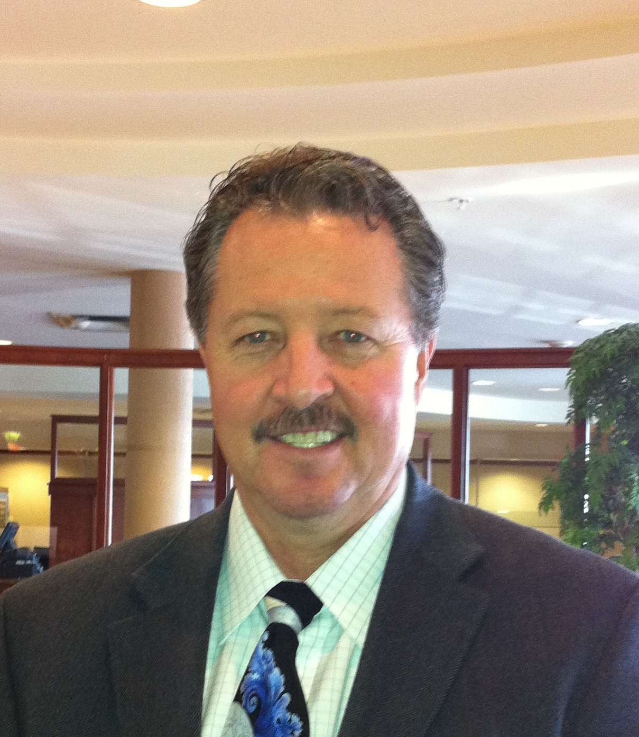

BIO: Mr. McGinty is the Senior Manager Business Development SCR NO_{x} Emission Control Systems for Mitsubishi Power Systems Americas (MPSA), and is responsible for NO_{x} emission control systems throughout the Americas including the United States, Canada and South America. He has been involved in the emission control marketplace spanning more than 25 years and has worked in management, project management, commissioning & startup and sales & marketing for highly complex pre combustion and catalyst based post combustion emission control systems in the power and petrochemical industry. His field of expertise includes Selective Catalytic Reductions Systems, Low NO_{x} Burner Systems and Continuous Emission Monitoring Systems associated with large power boilers, simple cycle and combined cycle gas turbines, auxiliary boilers and refinery process heaters. His experience in the commissioning & startup world for both SCR systems and combustion based low NO_{x} burners encompass projects in the United State, Mexico, the Middle East and Asia. Prior to joining Mitsubishi, Robert’s work included various positions of increasing responsibility for national and international based emission control companies including Research Cottrell’s KVB and Environmental Service & Technologies’ Companies, Environmental Laboratories, Applied Utility Systems and Johnson Matthey.

ABSTRACT: For over 40 years Mitsubishi has been involved in the development, design and supply of SCR catalyst and SCR systems for the control of NO_{x}. Mitsubishi is considered one of the original pioneers of SCR systems and catalyst technology with more than 600 SCR systems operating worldwide. Mitsubishi catalyst technologies have been licensed globally with focus on the homogeneous honeycomb catalyst technology and joint development of plate catalyst technology. In 1989 Mitsubishi teamed with Corning to form the joint equity US based catalyst company Cormetech, to manufacture and supply extruded homogeneous honeycomb catalyst technology products. Mitsubishi continues to bring superior catalyst and SCR support system technologies to the world for control of NO_{x} pollution, ammonia slip control catalyst, and pollution control products for solid fuel based combustion systems.

Today’s environmental regulations are continuing to demand stringent NO_{x} emission controls in the gas turbine arena and industry is finding it necessary to install SCR systems on all sizes of gas turbines, from small single digit MW producing peaking turbines to large frame simple cycle gas turbines producing in excess of 200 MW with similar NO_{x} control requirements for combined cycle gas turbines.

This discussion will focus on fundamental SCR system design, catalyst selection, ammonia vaporizing & distribution technology, tempering air systems, and maintenance concerns for the long life and reliable control of NO_{x} from simple cycle and combined cycle gas turbine applications.

KELLY FLANNERY, ANDREW HEID and KRISTEN COOPER – VOGT POWER INTERNATIONAL

ABSTRACT: Kelly M. Flannery, Chief Thermal Engineer, Andrew Heid - Emission Catalyst Design Lead Engineer and Kristen Cooper - Simple Cycle Design Lead Engineer at Vogt Power International, will present their three product lines for emissions control from combustion turbine exhaust: 1) Simple Cycle Exhaust Catalyst System, 2) Combined Cycle HRSG Installation with Catalyst and 3) Steam Injection for NO_{x} Control.

GREG THOMAS – HACH

BIO: Greg Thomas Key Accounts Manager, Nuclear Power
MS Chemistry
Been with Orbisphere and now Hach for 25+ years

ABSTRACT: The presentation will briefly discuss amperometric and optical technology for the measurement of low level dissolved oxygen. Performance comparison data of the two technologies in steam cycle applications will be presented. Finally comparisons along with advantages / disadvantages will be discussed.

