Metso’s state of the art transmitter technology contributes to
the efficiency and profitability of Chinese paper mills

Recently, Metso has won several measurement orders from Chinese paper mills, like Jiangsu Jinhuang Paper Co., Ltd, Hebei Changtai Paper Industry Co., Ltd, Anhui Huatai Forest Pulp & Paper Co., Ltd, Guangdong Huatai Paper Co., Ltd, and Wuhan Jin Feng Huang Paper Industry Co., Ltd.
Metso has contracted with the Anhui Huatai Forest Pulp & Paper Co., Ltd. on the delivery of a dozen consistency transmitters, one of them being a Metso OC, an optical consistency transmitter. The upcoming delivery for the rebuilding of a pulp factory also includes several Metso SP (blade) and Metso Rotary transmitters, as well as equipment for cooking liquor measurement, among other things.
The Jiangsu Jinhuang Paper Co., Ltd. has ordered several Metso SP (blade) transmitters for a greenfield factory. A further customer for another greenfield project is the Hebei Changtai Paper Industry Co., Ltd. for whom a linerboard project as well as a plasterboard paper machine will be delivered. The Wuhan Jin Feng Huang Paper Industry Co., Ltd. is also among the recent major customers, making an order for two new board machines PM3 and PM5, as well as 16 Metso SP consistency transmitters. All the orders from the Chinese papermaking industry companies are due to be delivered in the autumn of 2012.

Inline consistency measurement has never been easier
The Metso optical consistency transmitter is a new member in the family that uses state of the art technology with a new design, offering reliable measurement at all times. In mechanical pulping (e.g. TMP, GW and CTMP) typical applications are grinders, cyclone cleaners, latency removal, screening, and low consistency refining. In chemical pulping, the new transmitter can be used for screening, washing, refining, and drying machine applications.
Inline consistency measurement has never been easier – the Metso OC employs the latest electronics technology with multiple optical fiber channels, using a single light source and optimal probe design for reliable measurement. Installation is simple and safe. Inserting and retracting the measurement probe is safe and easy, even in high process pressure. The Metso OC can be calibrated with just one laboratory sample. No regular maintenance is needed – the entire transmitter-related cost remains low.

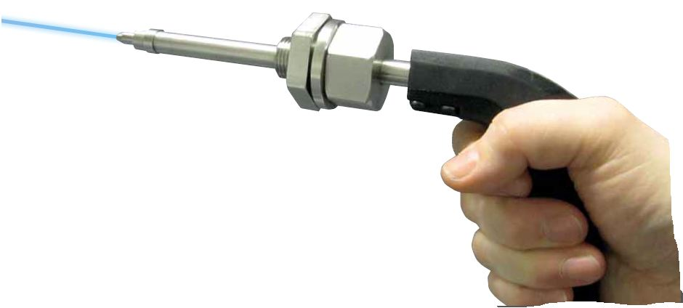

http://www.eibis.com/eibis/eibiswww/eibispix/4968-full.jpg

Metso is a global supplier of sustainable technology and services for mining, construction, power generation, automation, recycling and the pulp and paper industries. We have about 30,000 employees in more than 50 countries. www.metso.com

Metso’s automation professionals specialize in process industry flow control solutions, automation and information management systems and applications, and lifecycle services. The main products include, for example, control valves, automation systems, quality control systems and measurement solutions.

For more information, please contact:

Bengt B. Johansson, Product Manager Consistency Products
Tel. +46 703 421 240, bengt.b.johansson@metso.com

Heikki J. Föhr, Product Specialist
Tel. +358 50 551 0730, heikki.j.fohr@metso.com

