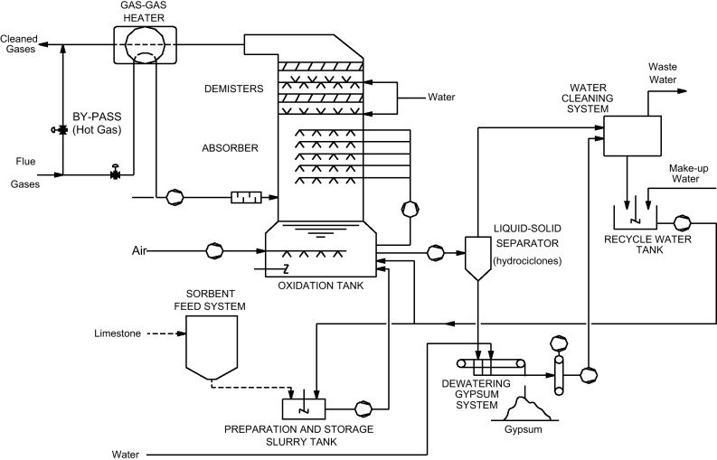

Smoke Stack

Coating Cost: $357,259.17

Duct Work

Coating Cost: $215,429.58

Scrubber

Coating Cost: $666,259.37

Gas to Gas Heater

Coating Cost: $126,114.79

Holding Tank

Coating Cost: $207,182.94

Xx

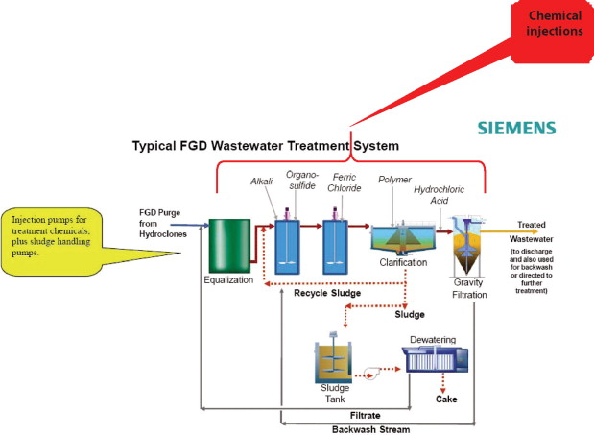

Sludge Tank

Coating Cost: $40,535.79

Clarifier

Coating Cost: $132,416.92

Treatment Tank 1 & 2

Coating Cost: $40,535.79

Waste Water Tank

Coating Cost: $81,071.58

Mcilvaine power point in decisive classification