Technical File: Vogmask VM

QR-05-01

Revision 2 Draft A

July xx, 2018

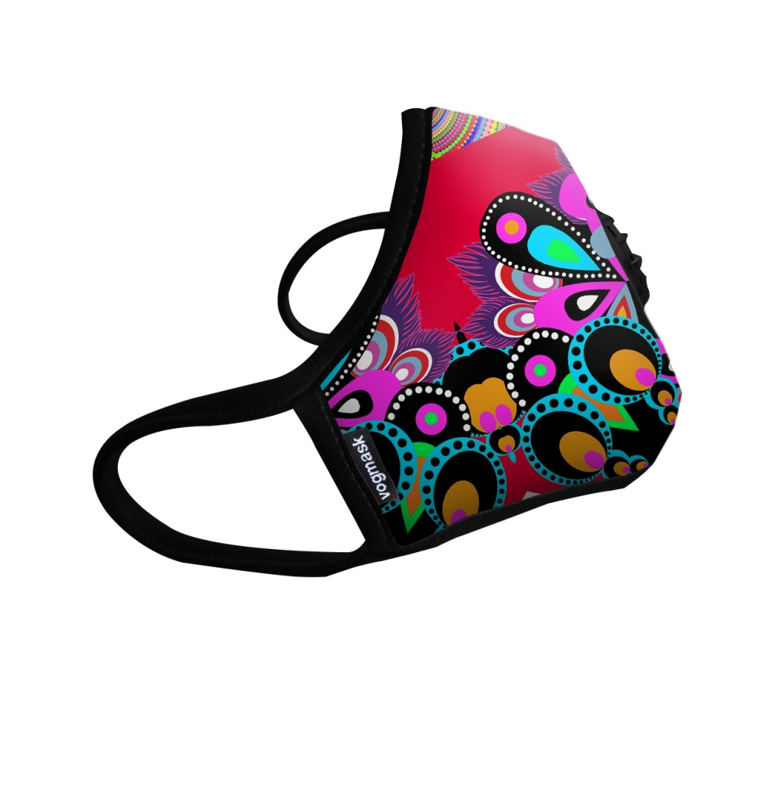

Prepared by:   
 Wendover H. Brown

Approved by:   
 Marc C. Brown

# Table of Contents

1.0 Table of Contents 2

2.0 Revision History TBD

3.0 Product Description TBD

4.0 Risk Assessment TBD

5.0 Essential Health and Safety Requirements (EHSR) Checklist TBD

6.0 Drawings TBD

7.0 List of Components TBD

8.0 Test Reports TBD

9.0 Quality Plan TBD

10.0 Marking TBD

11.0 User Information TBD

12.0 PPE To FIt An Indvidual User TBD

13.0 Draft EC Declaration of Conformity TBD

14.0 Letter of Authorization TBD

A Failure Modes and Effects Analysis (FMEA) TBD

B Safety Data Sheets TBD

C EHSR Checklist TBD

D Test Reports TBD

E User Instructions TBD

F Individual Packaging and Shipping Carton TBD

G Quality Plan TBD

H Draft EC Declaration of Conformity TBD

Tables

Table 7‑1. Components of Vogmask - Assembly TBD

Table 7‑2. Components of Vogmask Head Strap (Head Harness) Accessory TBD

Table 11‑1. Markings on Individual Packaging TBD

Figures

Figure 6‑1. Photograph of Vogmask VMCV TBD

Figure 6‑2. Vogmask VMCV Exploded View Assembly (Single Valve Configuration Shown) TBD

Figure 6‑3. Vogmask Sew-in Tag TBD

Figure 6‑4. Dimensions of Size 1 Vogmask VMCV TBD

Figure 6‑5. Dimensions of Size 2 Vogmask VMCV, VM Organic & VMC2V Organic TBD

Figure 6‑6. Dimensions of Size 3 Vogmask VMCV TBD

Figure 6‑7. Dimensions of Size 4 Vogmask VMCV, VM Organic & VMC2V Organic TBD

Figure 6‑8. Sampling of Various Graphic Designs of Vogmask VMCV TBD

Figure 6‑9. Vogmask Head Strap (Head Harness) Accessory TBD

Figure 10‑1. Marking for Vogmask VMCV, Size 1 TBD

Figure 10‑2. Marking for Vogmask VMCV Size 2 TBD

Figure 10‑3. Marking for Vogmask VMCV Size 3 TBD

Figure 10‑4. Marking for Vogmask VMCV Size 4 TBD

Figure 10‑5. Marking for Vogmask VM Organic Size 2 TBD

Figure 10‑6. Marking for Vogmask VM Organic Size 4 TBD

Figure 10‑7. Marking for Vogmask VMC2V Organic Size 2 TBD

Figure 10‑8. Marking for Vogmask VMC2V Organic Size 4 TBD

Figure 10‑9. Vogmask VM Product Stamp Location Diagram TBD

Figure 11‑1. User Information in English TBD

Technical File: Vogmask

# Revision History

| **Revision Number** | **Revision Date** | **Pages /Sections Revised** | **Revision Description** |
| --- | --- | --- | --- |
| 2 | 3/xx/18 | All | The “N99” naming convention for product was changed to “VM”. The section numbers were revised to align with BSI Form PF593.  Transitioned from Directive 89/686/EEC to Regulation (EU) 2016/425. This involved reorganizing the section numbering. |
| Section 6.1 | Revised the sizes for masks and added new variant. Was Section 4.1. |
| Section 7.1 | New outer faceblank material and filter in VMCV. Was Section 5.1. |
| Section 8.0 | Added reference to new test report number for VMCV. Was Section 7.0. |
| Section 10.0 | Added markings for new configuration of VMCV size 3. Was Section 8.0. |
| Section 11.0 | Revised to meet PPE Regulation requirements and change naming convention. Was Section 11.0. |
| Section 13.0 | Removed the term “draft”. |
| Appendix B | New microfiber outer faceblank specification. |
| Appendix C | Updated to EHSR checklist per PPE Regulation. |
| Appendix D | Added new test report for VMCV. |
| Appendix E | Updated User Instructions. |
| Appendix F | Updated packaging and shipping specifications. |
| Appendix G | Updated quality plans to revised mask sizes. Attachment B-2 Welcron QC Plan has revised acceptance criteria for filter specification and markings on valves. Attachment B-2 Welcron QC Plan section 8.1 removes step to verify hole diameter. |
|  |
| Appendix H | Previous content removed. Now contains Declaration of Conformity. Revised mask sizes. Removed the term “draft”. . |
| Appendix I | No longer used. Previous content moved to Appendix H. |
| 1 | 3/22/17 | Section 3.0 | Added N99 Product Family descriptions for the Vogmask N99 Organic, and N99C2V Organic. |
|  |  | Section 4.0 | Added variant sizes and configurations. Updated Figures 4.2 and 4.3. |
|  |  | Section 5.0 | Updated List of Components, Table-5.1 for the new product variants. Updated Appendix B to include Safety Data Sheets for new materials used for the Trim and Ear Loops (All Variants) and Vogmask N99 Organic and N99C2V Organic. |
|  |  | Section 7.0 | Added BSI Test Report#8622242 to Appendix D for FFP2 Testing on Vogmask N99 Organic and N99C2V Organic. |
|  |  | Section 8.0 | Updated Product Marking to accommodate new variants. |
|  |  | Section 9.0 | Added new language to user information (Chinese). Updated Figure-9.1 to apply to valved and non-valved masks. See Appendix E. |
|  |  | Section 10.0 | Updated the Ohlone Quality Plan, Operational Process Flow to specify requirements for the valve installation process. |
|  | Updated Supplier Quality Control Plans (Welcron/Pacom) to include new acceptance criteria for variants containing valves. |
|  | See Appendix G, Attachment B-1, Attachment B-2. |
|  |  | Section 13.0 | Updated the Draft EC Declaration of Conformity to include new project variants and countries of destination. See Appendix I |
|  |  | Appendix F | Added Individual Packaging US and China Retail Boxes. |
| 0 | 6/28/16 | All | Original Release |

# Product Family Description

Vogmask is first to market with a concept of combining fashion and functionality in filtering masks for general use to protect from particles such as PM 2.5, pollen, dust, and other non-oil airborne contaminants.

Ohlone Press has established a manufacturing partner, Welcron Korea with expertise in filtering textile technology and manufacturing of personal protective products. Welcron has an ISO 9001 certified quality manufacturing system and currently manufactures and packages Vogmask. Printed User Instructions, box for individual units of production, production planning, secondary quality inspection, and exporting are performed by award-winning printer and packagers, Pacom Korea. The product has received certification with Korean Ministry of Food and Drug Safety (MFDS), and approval as a China GB2626-2006 KN95 particulate respirator.

Vogmask is a filtering half mask offering comfort, fit, efficiency, and style. The Vogmask VM product family consists of three (3) different variants which include: VMCV, VM Organic and VMC2V Organic.

The Vogmask VMCV design features printed outer microfiber layer, middle layer of N99 PP based filtering textile, middle layer of coconut shell derived carbon bonded by acrylic to polyester filter, woven inner polyester layer, coated aluminum nose wire, latex-free spandex trim and ear loops, polyester sew-in identifier tag, and optional microfiber head strap accessory. The VMCV contains one exhalation valve.

The Vogmask VM Organic design features printed 100% organic cotton outer layer, middle layer of N99 PP based filtering textile, 100% organic cotton inner layer, coated aluminum nose wire, latex-free spandex trim and ear loops, polyester sew-in identifier tag, and optional microfiber head strap accessory.

The Vogmask VMC2V Organic design features printed 100% organic cotton outer layer, middle layer of N99 PP based filtering textile, middle layer of coconut shell derived carbon bonded by acrylic to polyester filter, 100% organic cotton inner layer, coated aluminum nose wire, latex-free spandex trim and ear loops, polyester sew-in identifier tag, and optional microfiber head strap accessory. The VMC2V Organic contains two exhalation valves.

Vogmask is packaged in polybag, sealed, and inserted into individual packaging (cardboard box) with User Instructions. The individual packages are packed into cartons of 100 units per carton and palletized for export. Images of the individual packaging and the sticker labels that are applied to it are provided in Appendix F. A copy of the specification for the shipping carton and example carton markings are also provided in Appendix F.

APPLICANT DETAILS

Ohlone Press, LLC

1830 Leavenworth Street

San Francisco CA 94109 USA

Contact: Wendover H. Brown

Telephone: 001 650 678 8652

Email: [Wendover@Vogmask.com](mailto:Wendover@Vogmask.com)

MANUFACTURING SITE

Welcron Korea Inc.

12, 27-Rd, Digital-St, Guro-gu, Seoul, Korea

Email: [nike@Welcron.com](mailto:nike@Welcron.com)

Headquarters:

Welcron Korea Inc.

Guro-dong 212-214

Guro-gu, Seoul, Korea

Email: [Elvis@Welcron.com](mailto:Elvis@Welcron.com)

PRODUCTION MANAGEMENT, QUALITY ASSURANCE, PACKAGING

Mr. Lonestar Hwang

Pacom Korea, Inc.

8F Jellzone Tower II, 159-4 Jeongja-dong, Bundang-gu

Seongnam-si, Geonggi-Jo, Korea

Email: [Lonestar@gopacom.com](mailto:Lonestar@gopacom.com)

Telephone: 82 31 726 3666

NOTIFIED BODY

British Standards Institution - UK

Kitemark Court

Davy Avenue

Knowlhil

Milton Keynes

MK5 8PP

United Kingdom

Notified Body Number: 0086

APPLICABLE REGULATION

Regulation: Personal Protective Equipment (PPE) Regulation (EU) 2016/425.

Module B EU type-examination

Module C2 Conformity to type based on internal production control plus supervised product checks at random intervals

Directive Name: General Product Safety Directive 2001/95 EC

Standard for Testing: EN149:2001 + A1:2009

# Risk Assessment

The following is a functional description of the Vogmask and its intended use:

* + Particle filtering half mask to reduce exposures to airborne particulate matter.
  + Helps to protect from non-oil airborne particles such as dust, pollen, shavings, and particles found in air pollution.
  + The mask can also help reduce exposures to airborne biological particles such as mold.
  + Intended for general public use

Certain limitations apply to the use of the Vogmask product:

* + Follow fitting instructions carefully; filtering efficiency depends on proper fitting.
  + Do not use Vogmask for chemicals gases, vapors, oils, aerosols, oil based particles, or extremely high particle concentrations.
  + Does not eliminate the risk of illness, diseases, or infection.
  + Leakage will occur if facial hair passes under the face seal.
  + This product does not guarantee protection from illness or any harmful substance.

The only maintenance requirement for Vogmask is to mildly rinse outer and inner layer with water and small dot of mild liquid detergent.

The operating, shipping, and storage conditions for Vogmask are as follows:

* + Storage temperature range: -18 °C to 38 °C
  + Relative humidity for storage: <85 % RH
  + Expiration dating: 18 months. Korean Ministry of Food and Drug Safety has approved a standard expiration date of 3 years for Vogmask.

The product should be used, stored and maintained in accordance with User Instructions. If instructions are not followed by users, the product could fail to protect the wearer from airborne particulate matter.

Ohlone has performed a risk assessment for safety of the end user of the Vogmask product under the intended use, limitations, and conditions described above. This risk assessment was performed as part of an overall Design Failure Modes and Effects Analysis (DFMEA), which is provided in Appendix A. The completed risk assessment applies to all product variants (e.g. VMCV, VM Organic and VMC2V Organic).

# Essential Health and Safety Requirements (EHSR) Checklist

The EHSR Checklist is provided in Appendix C.

# Drawings

This section provides visual identification of the Vogmask VM product family. Information is provided separately for the Vogmask VM and its accessory Vogmask Head Strap.

## Vogmask VM

A photograph of a sample Vogmask featuring a printed graphic is shown in Figure 6‑1.

An exploded view illustration of the Vogmask assembly is provided in Figure 6‑2. Filtering materials are enclosed and protected on the inside by an inner faceblank and on the outside by an outer faceblank. The VMCV mask has a single three-piece exhalation valve installed (on one side of the mask) to allow air to escape with little resistance when the user exhales. The VMC2V Organic variant includes an additional three-piece exhalation valve on the opposite side of the mask for a total of 2 valves. The VM Organic variant does not contain exhalation valves. Vogmasks are held in place by means of ear loops. A coated aluminum wire nosepiece allows the mask to follow the contour of the user’s nose and face. As seen in Figure 6‑1, the Vogmask is affixed with a polyester Sew-in Tag. A close-up image of the Sew-in Tag is shown in Figure 6‑3.

Vogmask VM Product Family is offered in the following sizes and configurations.

|  |  |  |  |  |  |
| --- | --- | --- | --- | --- | --- |
| **Product ID** | **S** | **M** | **L** | **Carbon Filter** | **Exhalation**  **Valve (s)** |
| VMCV | X | X | X | Yes | 1 |
| VM Organic |  | X | X | No | 0 |
| VMC2V Organic |  | X | X | Yes | 2 |

The basic dimensions of the Vogmask sizes are provided in Figure 6‑4 through Figure 6‑6.

The outer layer is printed with colored graphics that are changed by Ohlone in manufacturing for fashion styling purposes. A number of different graphic prints are available and their number will increase as Ohlone seeks to provide attractive fashionable protective wear to its customers. All of these use the same combinations of ink for coloring the outer fabric, so the materials of construction do not change. Examples of various print graphics already available for the Vogmask VMCV are shown in Figure 6‑7.

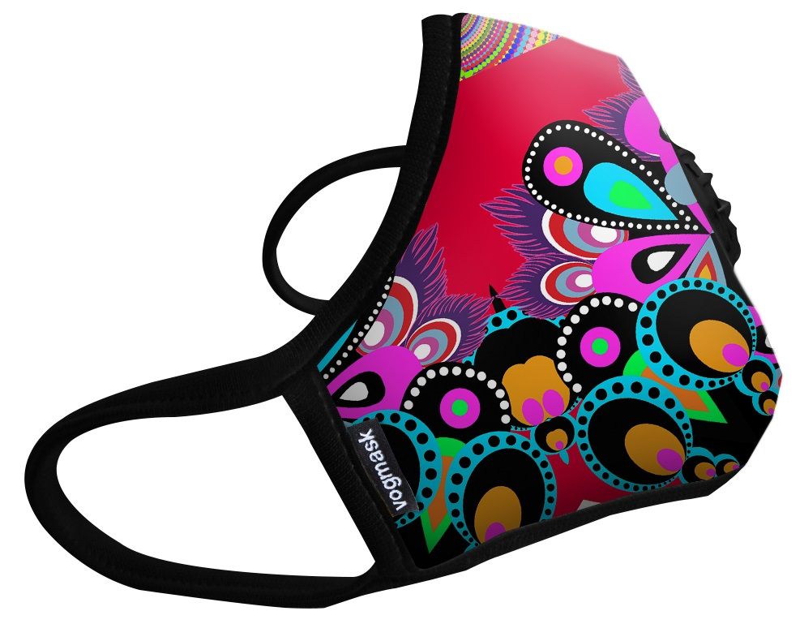

Figure 6‑1. Photograph of Vogmask VMCV

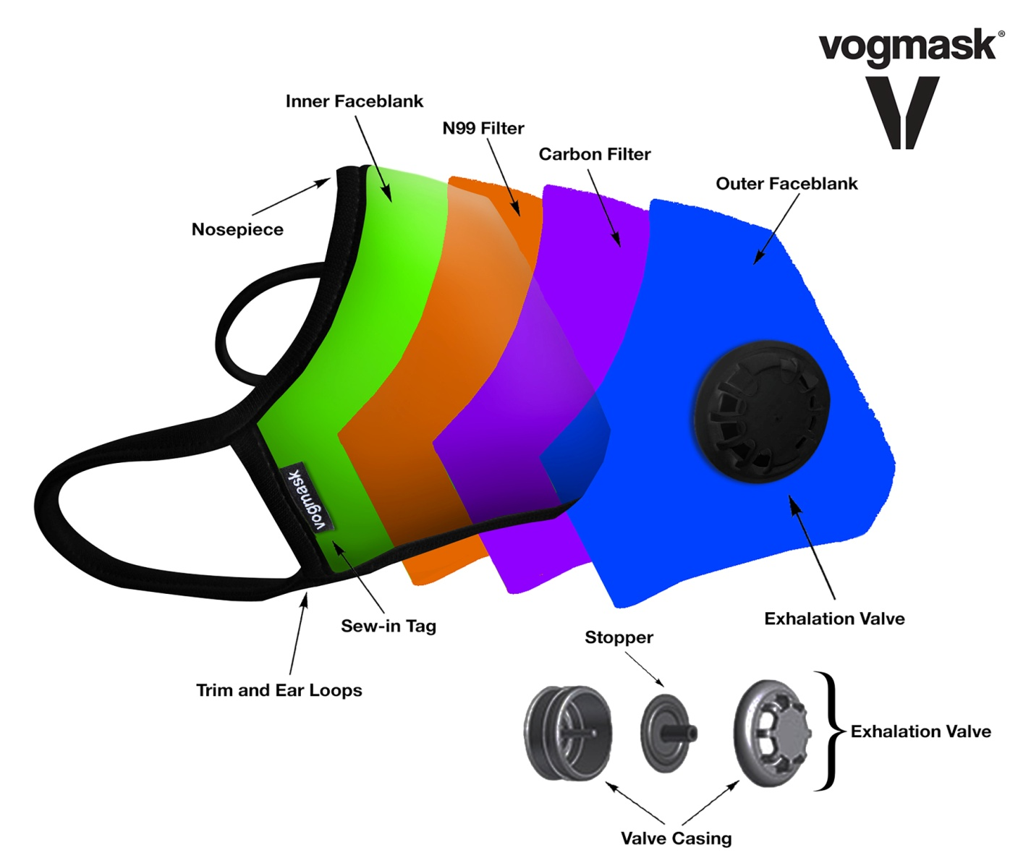

Figure 6‑2. Vogmask VMCV Exploded View Assembly (Single Valve Configuration Shown)



Figure 6‑3. Vogmask Sew-in Tag

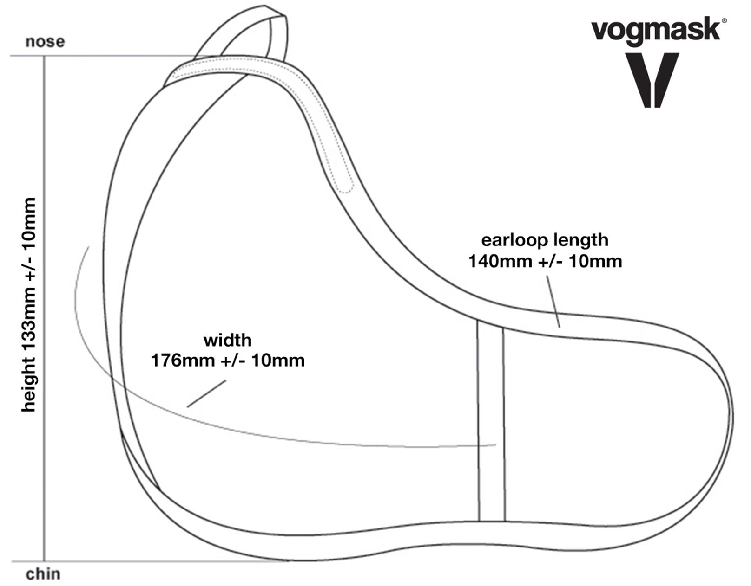

Figure 6‑4. Dimensions of Small Vogmask VMCV and Medium VM Organic & VMC2V Organic

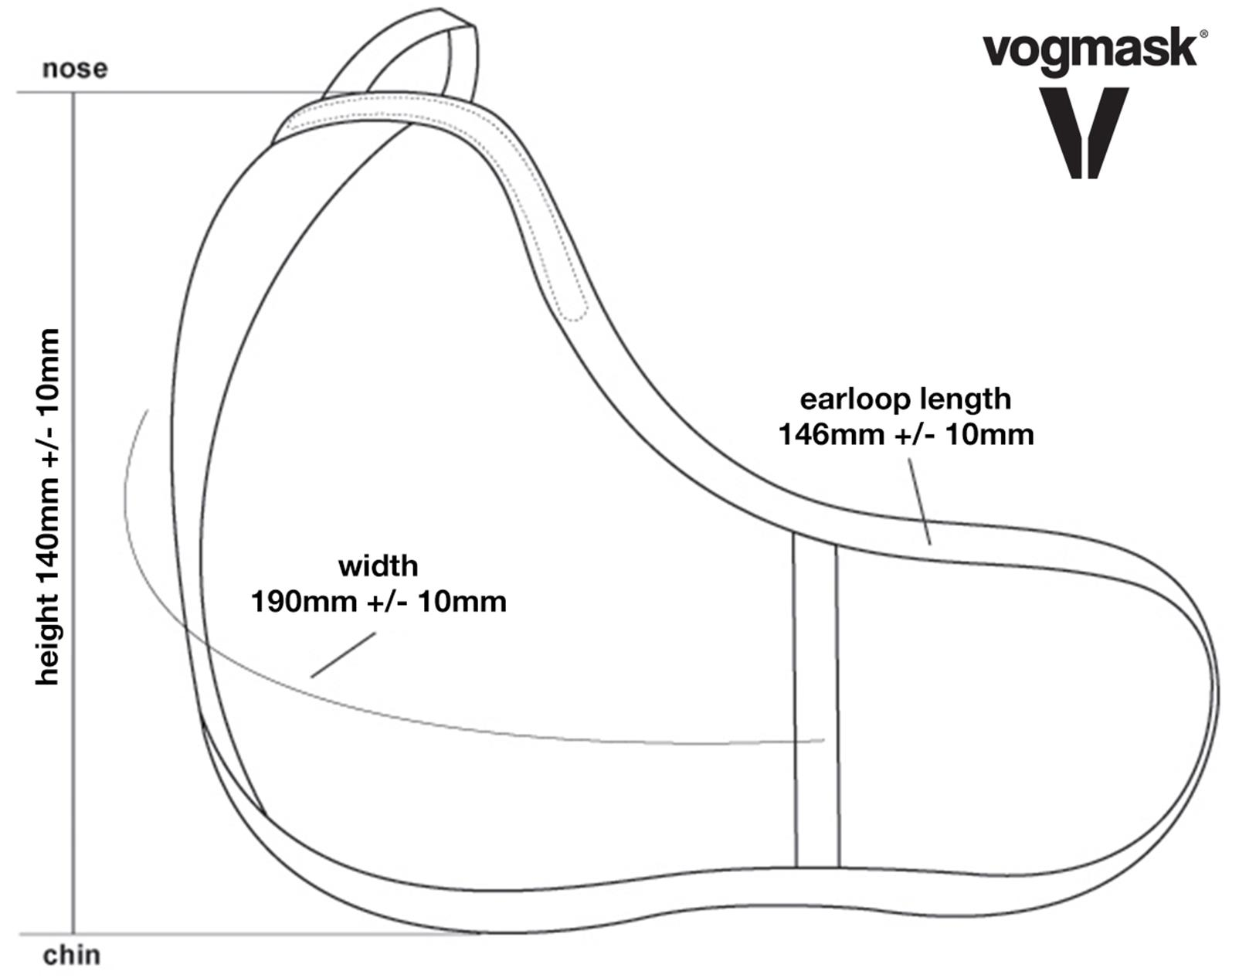

Figure 6‑5. Dimensions of Medium Vogmask VMCV

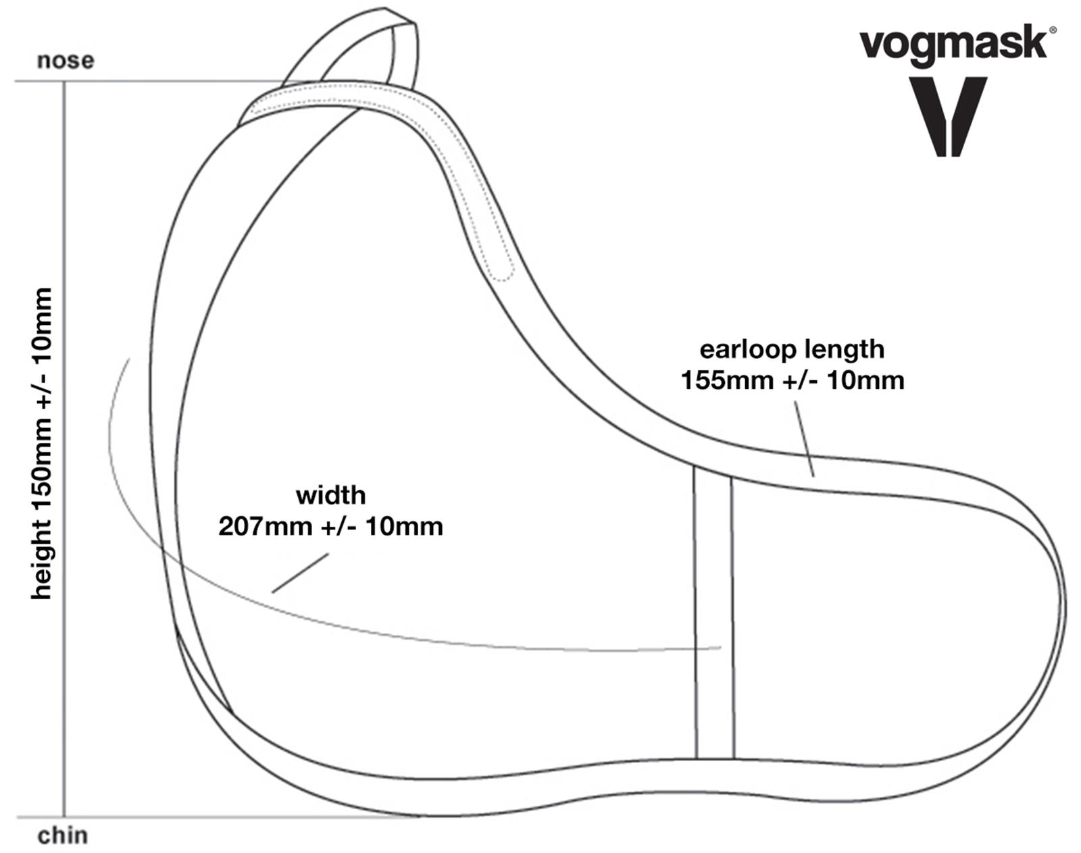

Figure 6‑6. Dimensions of Large Vogmask VMCV, VM Organic & VMC2V Organic

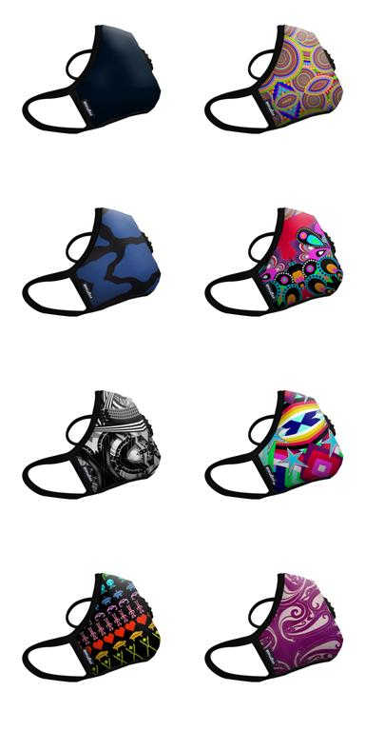

Figure 6‑7. Sampling of Various Graphic Designs of Vogmask VMCV

(Single Valve Configuration Shown, Graphic Designs Shown Here Are Samples and Not All Inclusive)

## Vogmask Head Strap (Head Harness) Accessory

A Vogmask Head Strap (head harness) is available as a separate accessory item to be worn by the user with any of the Vogmask variants. An illustration of the Vogmask Harness is provided in Figure 6‑8.

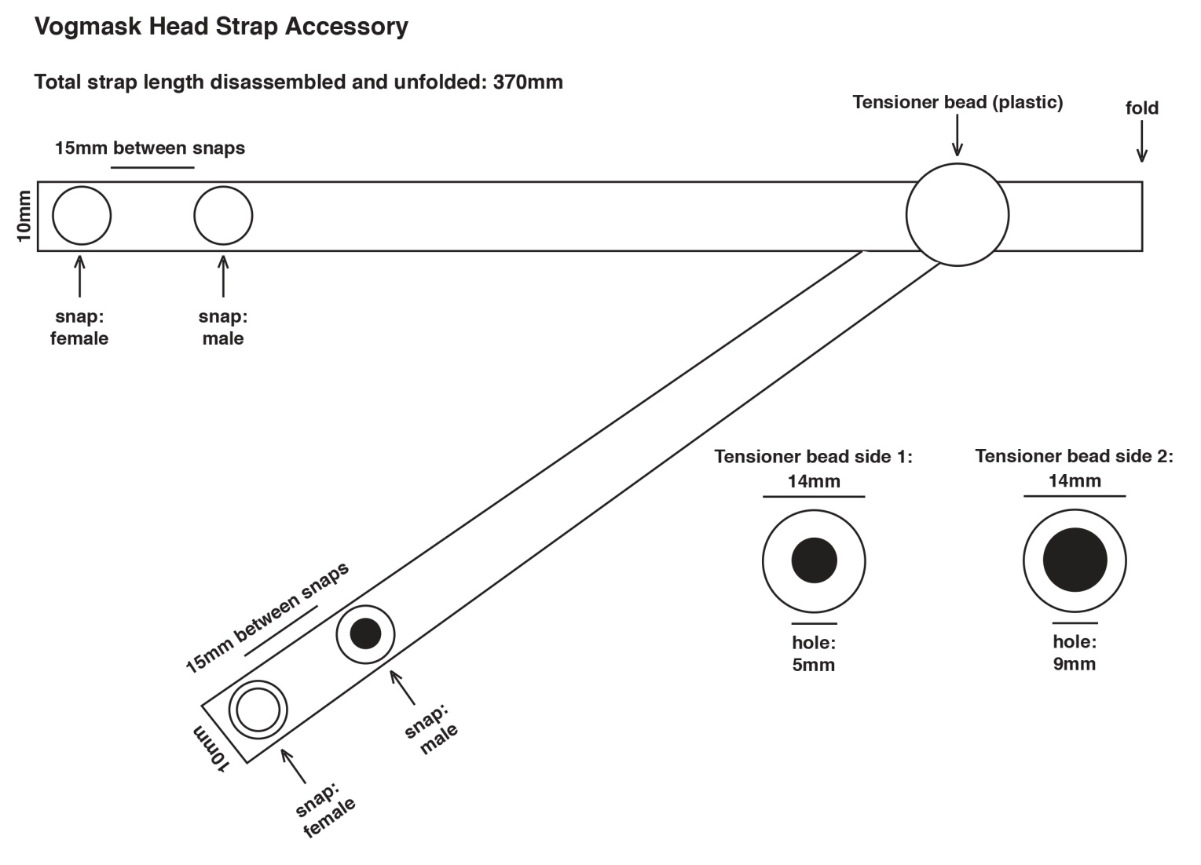

Figure 6‑8. Vogmask Head Strap (Head Harness) Accessory

# List of Components

## Vogmask VM Mask

This section identifies the components used in the Vogmask assembly. Each of the components included in the Vogmask VM assembly are listed in Table 7‑1. Copies of all available material safety data sheets (SDS) are provided in Appendix B. Some SDS are referenced for multiple components, in which case the SDS is included in the Appendix only once.

| **Table 7‑.** Components of Vogmask VM - Assembly | | | | | |
| --- | --- | --- | --- | --- | --- |
| Part Description | Part Number | Qty / Unit | Manufacturer | Material Description | Component Specification Reference |
| **Vogmask Filtering Half Mask** | | | | | |
| Outer Faceblank | VOG021 | 1 | Welcron |  |  |
| Outer Faceblank  ***VMCV only*** | S-501 | 1 | Welcron | Polyester Microfiber  (Warp Knitting Fabric) sourced from Korea Microfiber, Ltd. | * Welcron Information and Certification.pdf * [OUT LAYER]S-501 MSDS EN[1].pdf |
| Outer Faceblank  ***VMCV only (black material)*** | S-501-P | 1 | Welcron | Polyester Microfiber  (Warp Knitting Fabric) sourced from Korea Microfiber, Ltd. | * [OUT LAYER]S-501P BLACK MSDS EN[1].pdf |
| Outer Faceblank  ***VM Organic, VMC2V Organic only*** | O-100 | 1 | Knitwo Company | 100% Cotton  - circular knit interlock | * [INNER LAYER - OUTER LAYER] Organic fabric specification_SDS.pdf * [INNER LAYER - OUTER LAYER_ORGANIC] ASR-2A_MSDS.pdf * [INNER LAYER - OUTER LAYER_ORGANIC] COM-A CONC_MSDS.pdf |
| Infused Dye for Print Design | T741100  T741200  T741300  T741400 | A/R | Nicewin | Epson Ink Pack T741100  Epson Ink Pack T741200  Epson Ink Pack T741300  Epson Ink Pack T741400 | * Epson Blk_T741100_SDS.pdf * Epson Cyan_T471200_SDS.pdf * Epson Magenta_T741300_SDS.pdf * Epson Yellow_T741400_SDS.pdf   (See Note 1) |
| Outer Faceblank Print Artwork | Per Ohlone Purchase Order | N/A | Ohlone Press, LLC | N/A | N/A |
| Carbon Filter  ***VMCV and VMC2V Organic only*** | CARBON FILTER | 1 | Chang Myoung Textile Co. | Coconut Shell Derived Carbon / Acrylic Binder / Polyester Fabric | Carbon filter test report(En)[1].pdf |
| VMCV Filter  ***VMCV only*** | MF0030FS(N-95) | 1 | Welcron | Microfiber made from 100% Polypropylene | * Technical Data for MF0030FS(N-95).pdf * [FILTER]Polypropylene_MSDS[1].pdf |
| VM Organic and VMC2V Organic Filter  ***VM Organic and VMC2V Organic only*** | MF0040FS(N99) | 1 | Welcron | Microfiber made from 100% Polypropylene | * Technical Data for N99.pdf * [FILTER]Polypropylene_MSDS[1].pdf |
| Inner Faceblank  ***VMCV only*** | Inner Layer | 1 | Dae Woo Textile | 100% Polyester, 160 gsm, 147cm width  Woven, circular knit, 4row mesh type | [Polyester]msds.pdf |
| Inner Faceblank  ***VM Organic and VMC2V Organic only*** | O-100 | 1 | Knitwo Company | 100% Cotton  - circular knit interlock | * [INNER LAYER - OUTER LAYER] Organic fabric specification * [INNER LAYER - OUTER LAYER_ORGANIC] ASR-2A_MSDS.pdf * [INNER LAYER - OUTER LAYER_ORGANIC] COM-A CONC_MSDS |
| Nosepiece | Aluminum Noseband | 1 | Victory Industry | Coated Aluminum | Not available |
| Exhalation Valve  ***VMCV and VMC2V Organic only***  *\*Note: Variants containing “2V,” require 2 valves.* | V-Korea-Logo /2 (Black)  V-Korea-Logo /2 (White) | 1* | Dae Young ENC. | ABS Valve Casing (two piece), with Logo  Silicone Rubber Stopper | Nelson Labs, Valve Leakage Test 823262-RPT.pdf |
| Trim and Ear Loops | RIB (Tighter) | 1 | Jin Woo Textile | Cotton 94% / Polyurethane 6%  Circular knit | [Spandex]Creora MSDS(20140428)_EU_T1_Revised.pdf |
| Sew-in Tag | LDB0134 | 1 | H&KOREA Co., LTD | Polyester | Not available |
| **Vogmask Filtering Half Mask Packaging** | | | | | |
| Printed Box | 400BV | 1 | Pacom | Printed, coated and die cut box |  |
| Box, white paperboard | 400 gsm BV White Paper Board | 1 | Han Chang Paper | 400 gsm BV White Paper Board | Not available |
| Ink for Printed Box | 1333-86-4  147-14-8  5281-04-9  6358-85-6 | A/R | Dai-Han Ink Co., LTD | Plus Kleentec (QD) Black  Plus Kleentec (QD) Cyan  Plus Kleentec (QD) Magenta  Plus Kleentec (QD) Yellow | * PKT(QD) BLACK_GHS_MSDS_(Eng).pdf * PKT(QD) CYAN_GHS_MSDS_(Eng).pdf * PKT(QD) MAGENTA_GHS_MSDS_(Eng).pdf * PKT(QD) YELLOW_GHS_MSDS_(Eng).pdf |
| Printed Box Print Artwork | Per Ohlone Purchase Order | N/A | Ohlone Press, LLC | N/A | N/A |
| User Instructions | 100WF | 1 | Pacom | Printed 45cm x 20cm and folded to 9cm x 10cm finished size |  |
| Paper | 100 gsm gloss art paper | 1 | Han-sol Paper Co. | 100gsm gloss art paper | Not available |
| Ink for Printing Insert | 1333-86-4  147-14-8  5281-04-9  6358-85-6 | A/R | Dai-Han Ink Co., LTD | Plus Kleentec (QD) Black  Plus Kleentec (QD) Cyan  Plus Kleentec (QD) Magenta  Plus Kleentec (QD) Yellow | * PKT(QD) BLACK_GHS_MSDS_(Eng).pdf * PKT(QD) CYAN_GHS_MSDS_(Eng).pdf * PKT(QD) MAGENTA_GHS_MSDS_(Eng).pdf * PKT(QD) YELLOW_GHS_MSDS_(Eng).pdf |
| Poly Bag | PEP1385 | 1 | Sindoo Co., LTD | Polypropylene / Acrylic PSA |  |
| Polybag (poly bag film) | SEETEC-PP | 1 | Lotte Chemical | Polypropylene | * [Polybag film] Certificate of Analyisis.jpg * [POLYBAG]RT15R-U1602-003-E-ATR-802_ATR-804_6대[2].PDF |
| Barcode Label | 100G1 | 1 | Pacom | Printed and die cut to 10.5cm x 2.8cm |  |
| Barcode Label Stock | 100G | 1 | Se-rim Tape | 100 gsm gloss sticker paper | Not available |
| Ink for Label Printing | 1333-86-4 | A/R | Dai-Han Ink Co., LTD | Plus Kleentec (QD) Black | PKT(QD) BLACK_GHS_MSDS_(Eng).pdf |
| Size Label | 100G | 1 | Pacom | size: 2.3cm diam |  |
| Size Label Stock | 100G | 1 | Se-rim Tape | 100 gsm gloss sticker paper | Not available |
| Ink for Size Label Printing | 1333-86 | A/R | Dai-Han Ink Co., LTD | Plus Kleentec (QD) Black | PKT(QD) BLACK_GHS_MSDS_(Eng).pdf |
| Shipping Carton |  | 1/100 | Pacom | Printed and folded, Size: 37cm x 49cm x 21cm |  |
| Carton | Corrugated paper board, AB FLUTE, DOUBLE WALL, | 1/100 | Samjung Package | KLB/SS/KK  KLB -175gsm, S – 120gsm, K – 180gsm.  Carton size: 37cm x 49cm x 21cm | Not available |
| Carton Printing Ink | 1333-86 | A/R | Dai-Han Ink Co., LTD | Plus Kleentec (QD) Black | PKT(QD) BLACK_GHS_MSDS_(Eng).pdf |

Notes:

1. These inks applied to polyester fabrics are established through testing programs as being safe for close contact with skin (see information on Oeko-Tex Standard testing provided on Page 36 of Appendix B). The inks are accepted as suitable for use on media through which air is inhaled based on the mechanism by which the ink is transferred to the fabric. The printing method used is dye sublimation printing. With this method, the ink is infused into the structure of the polyester fibers that it is applied to. This is in contrast to more traditional printing methods where the ink is transferred to the surface of the fibers. With dye sublimation printing the image is transferred to the fabric permanently, will not peel or flake, and cannot be washed out. Based on this, the hazards associated with breathing through the printed fabric are considered to be no greater than the hazards associated with close skin contact.

## Vogmask Head Strap (Head Harness) Accessory

Components used in the Vogmask Head Strap (Head Harness) Accessory are listed in Table 7-2. Copies of all available material safety data sheets (SDS) are provided in Appendix B.

|  |  |  |  |  |  |
| --- | --- | --- | --- | --- | --- |
| **Table 7‑.** Components of Vogmask Head Strap (Head Harness) Accessory | | | | | |
| Component | Part Number | Qty / Unit | Manufacturer | Material | Specification Reference |
| **Vogmask Head Strap Accessory** | | | | | |
| Strap | RIB | 370 mm | Jin Woo Textile | Cotton (94%) + Polyurethane (6%) | Not available |
| Tensioner Bead, 2-piece | PP02 | 1 | Hwasung&JJR Sports | Polypropylene | Not available |
| Snap, Female | ACT02 | 2 | Hwasung&JJR Sports | Acetyl | Not available |
| Snap, Male | ACT02 | 2 | Hwasung&JJR Sports | Acetyl | Not available |
| **Vogmask Head Strap Packaging** | | | | | |
| Poly Bag | PEP1385 | 1 | Sindoo Co., Ltd. | Polypropylene / Acrylic PSA |  |
| Polybag (poly bag film) | SEETEC-PP | 1 | Lotte Chemical | Polypropylene | [Polybag film] Certificate of Analyisis.jpg |
| Sticker | 100G | 1 | Pacom |  |  |
| Paper Label Stock | 100G | 1 | Se-rim Tape | 100 gsm gloss sticker paper | Not available |
| Ink for Sticker | 1333-86-4 | A/R | Dai-Han Ink Co., LTD | Plus Kleentec (QD) Black | PKT(QD) BLACK_GHS_MSDS_(Eng).pdf |

# Test Reports

BSI Test Reports 8441578, Issue 2 and 8622242 are provided in Appendix D.

# Quality Plan

The Quality Plan is provided in Appendix G.

# Marking

The marking and applicable sizes for Vogmask VMCV, VM Organic and VMC2V Organic are shown in Figure 10‑1through 8. The location of the marking on the product is identified in Figure 10‑9.

|  |  |
| --- | --- |
|  | Figure 10‑. Marking for Vogmask VMCV, Size Small |
|  | Figure 10‑. Marking for Vogmask VMCV Size Medium |
|  | Figure 10‑3. Marking for Vogmask VMCV Size Large |

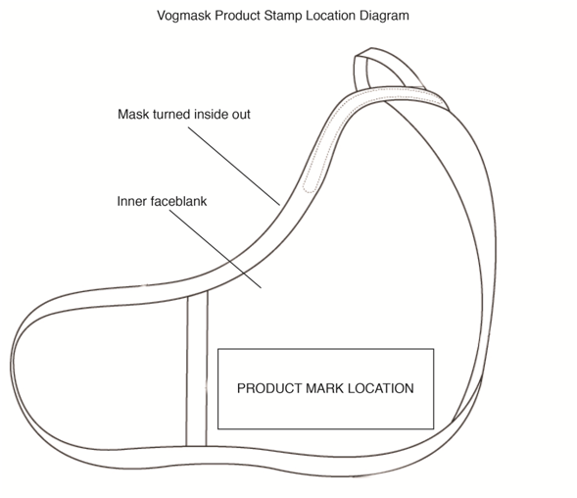

Figure 10‑9. Vogmask VM Product Stamp Location Diagram

# User Information

A fold-out paper insert containing user information in ten (10) languages is provided with each individually packaged Vogmask. The ten languages are: English, German, Italian, French, Polish, Dutch, Spanish, Swedish, Finnish, and Chinese. The user information is provided in Figure 11‑1 in English. Copies in all ten available languages are provided in Appendix E.

The user information includes the following information:

* + Name and address of the manufacturer, Ohlone
  + Storage, use, cleaning, maintenance and servicing information.
  + Explanation of the significance of pictograms.
  + Name, Address and Number of Notified Body involved in the design evaluation

A copy of the information printed on the individual packaging is provided in Appendix F.

Table 11‑1 provides an explanation of the significance of the markings on the individual packaging.

| **Table 11‑.** Markings on Individual Packaging | |
| --- | --- |
| hourglass.jpg | Use by date (on package) |
| thermometer.jpg | Temperature reading for storage -18°C to +38°C |
| umbrella.jpg | Relative humidity for storage <85% RH |
| book.jpg | Carefully read user instructions inside package |
| vogmask.jpg | Registered trademark of Ohlone Press LLC |

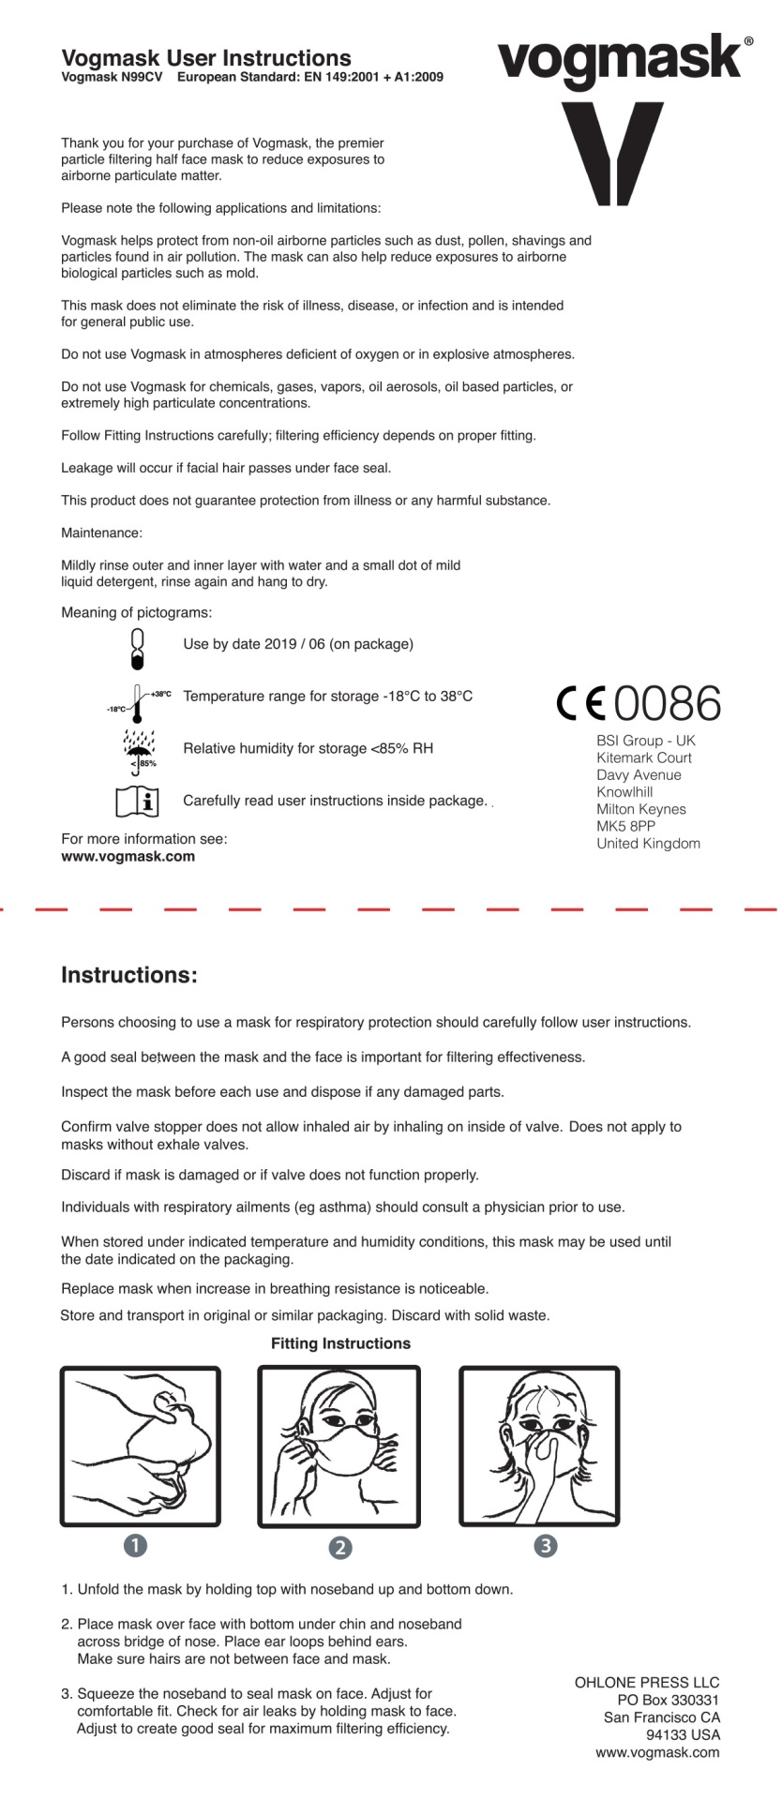

Figure 11‑1. User Information in English

# PPE to Fit an Individual User

This section is not applicable to this product. The Vogmask VM product line needs no additional measures to ensure compliance to fit an individual user. Instructions are provided in order for the user to determine the fit.

# EC Declaration of Conformity

The EC Declaration of Conformity is provided in Appendix H.

# Letter of Authorization

A Letter of Authorization is not required. Ohlone Press, LLC has compiled the Technical File and has submitted the application for CE marking.

###### Failure Modes and Effects Analysis (FMEA)

###### Safety Data Sheets

This appendix contains material safety data sheets for the components identified in Section 7.0.

###### EHSR Checklist

###### Test Reports

This appendix contains BSI Test Reports 8441578, Issue 2 and 8622242.

###### User Instructions

###### Individual Packaging and Shipping Carton

###### Quality Plan

###### EC Declaration of Conformity

Name of Firm: Ohlone Press LLC

Address of firm: 1830 Leavenworth Street, San Francisco CA 94109 USA

Contact Name: Wendover H. Brown Position: Partner

Product Description:

VOGMASK filtering half mask to protect against particles

Unique Identity:

|  |  |  |  |  |
| --- | --- | --- | --- | --- |
| **VM Product Family** | **Configurations** | | | |
| **Product ID** | **1** | **2** | **3** | **4** |
| VMCV | X | X | X | X |
| VM Organic |  | X |  | X |
| VMC2V Organic |  | X |  | X |

Regulation: Personal Protective Equipment (PPE) Regulation (EU) 2016/425.

Module B EU type-examination

Module C2 Conformity to type based on internal production control plus supervised product checks at random intervals

Standard for Testing: EN 149:2001 +A1:2009

Declaration by Manufacturer:

In making this application, we declare acceptance of and conformity with all the undertakings

contained in the Regulation including the presentation of the required technical documentation, a

controlled copy of which is supplied to the Notified Body with this application. We agree to

abide by the Conditions of Contract for the Service of a Notified Body under EC Regulation.

Notified Body Number: 0086

British Standards Institution - UK

Kitemark Court, Davy Avenue, Knowlhil

Milton Keynes, MK5 8PP

United Kingdom

Countries of Destination: UK, France, Germany, Belgium, The Netherlands, Italy, Spain,

Germany, Finland, Poland and China.

For and on behalf of: Ohlone Press LLC

Authorized signatory:_________________________________________

Name: Wendover H. Brown Position: Partner

Date: _3/xx/18________________