Mask Reuse Webinar

Panelists

Wallace Leung Polytechnic University, Hung Hom, Hong Kong

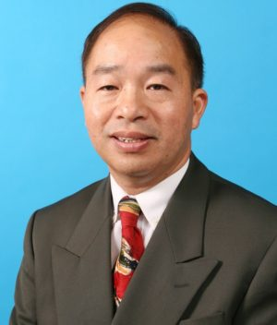

Christine Sun President of Waterloo Filtration Institute



David Shelep, Consultant Paramount Sciences



Jim Agalloco, President Agalloco Associates

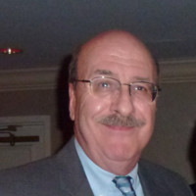

Barry Garfinkle, Principal at Barry Garfinkle & Associates

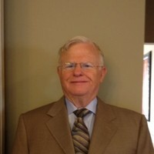

Jeff Mathers, Director of Global Marketing Purafil

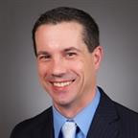

Bob McIlvaine, President McIlvaine Company

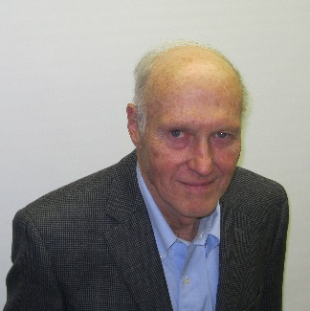

Agenda

Three Billion People Wearing Reusable Masks

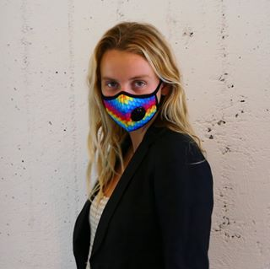

Mask Design

* Overview – Wallace Leung
* Mask Technology - Christine Sun

Decontamination Processes

* H202 - Jim Agalloco
* Cl02 - David Shelep

New Media

* Virus Destruction - Jeff Mathers
* Reusable Media- Bob McIlvaine

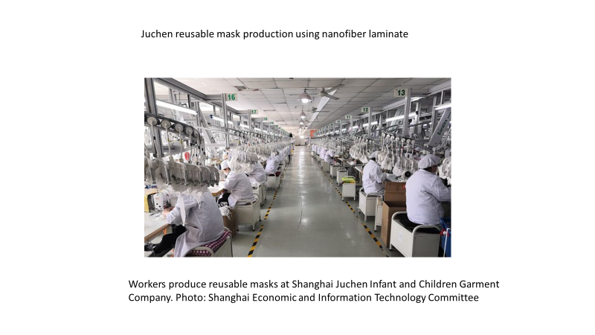

Summary and Discussion

Going Forward